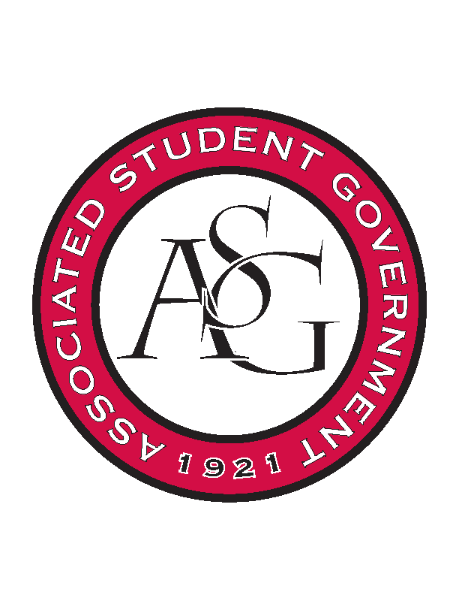
Associated Student Government

Executive Council Meeting Minutes

Monday November 23, 2015 | 12:30 p.m.

- Call To Order (12:29)
- Roll Call
  - Morgan
  - Jody
  - Katherine
  - Jamie
  - Rainer
  - Ray
  - Scout
  - Jace
- Special Orders
  - ASG Advisor’s Report
    - ASG Comment Cards
      - Review comments. ASG desk has converted to digital file. Reach out to Rainer for copy.
    - Spring Exec Meeting
      - Respond to Ray’s Doodle calendar request
    - Welcome for Chancellor
      - Possibly meet with D.O.S. and Chancellor next semester. Follow up when all of exec is present to discuss.
- Reports and Discussion
  - Vice President’s Report
    - Chick-fil-a Pass out
      - Can’t do pass out at State of the students because it conflicts with Chik-fil a student night.
      - Possibly pass out sandwiches during finals week. Will follow up at next exec meeting
    - Old Main Oath
      - Sent to legislative branches to gain support.
    - Final Survival Guide Idea
      - Market to students resources available for “surviving” finals. Push out via social media, website, etc.
        - ELC
        - Class.uark.edu
        - Healthy eating habits
    - Committees
      - In the coming weeks committee apps will open up again.
    - Holiday Party
      - December 8th 7-9; remind branches to RSVP.
  - Treasurer’s Report
    - OFA Standing Rules
      - Will submit to legislative branches Spring semester.
    - Upcoming Events
      - Please keep upcoming events in mind.
  - Chair of the Senate’s Report
    - Vacancies
      - Potentially 5 vacancies in Senate.
      - Ask ASG Day – hopefully do it in the Spring
  - GSC Speaker
    - Law School Legislation
      - Separate from Senate to join GSC
      - Tuition transparency bill – discrepancy with graduate/law school fees for dual enrollment. UofA needs a written policy.
    - Blackboard
      - GSC communication via blackboard.
    - Vacancies
      - Potentially 12 vacancies. Will follow up with representatives one more time.
- Announcements
  - Potential for guest speaker next semester (collaboration with several other student groups on campus). More information coming soon.
- Adjournment (12:57)

