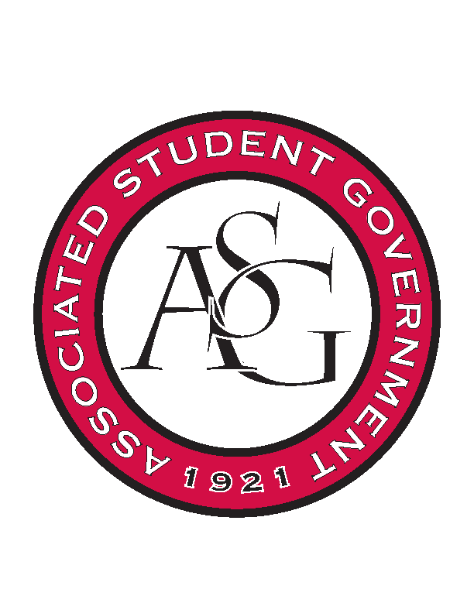
Associated Student Government

Executive Council Meeting

Monday November 30th, 2015 | 12:30 p.m.

- Call To Order
- Roll Call
- Special Orders
  - ASG Advisor’s Report
    - Spring Office Hours
      - Please make sure you set your office hours to everyone and also send them to Mrs. Jody.
    - Finals Week/Last Day
      - Wanted to check in on finals week and see when everyone’s last day is on campus. Reminder – if you plan on being in Fayetteville when class is not in session Union is closed Dec 19th-Jan 10th. You will not be able to access gizmo unless on campus.
    - December Events
      - Keep reminding your peers to come to our events. State of the Students and then the Holiday Party.
- Reports and Discussion
  - President’s Report
    - State of the Students
      - We have state of the students tomorrow night. Be sure to let your respective branches know.
    - PAB
      - Short notice PAB meeting.
  - Vice President’s Report
    - Holiday Party
      - Next Tuesday. Remind your branches to RSVP.
    - Board of Trustee’s
      - I heard Chancellor Ferritor give a Campus Update. They talked about enhancing the security and communication process for those students going overseas. Confident in current system but will go back and look at it.
      - Offering bachelors of arts and design. Online masters social work. Off campus bachelors supply chain. Partnership with China.
  - Secretary’s Report
    - New Exec. Time
      - Need to discuss a new exec. time slot. All the other times were taken up by other student organizations.
      - Other rooms in the union. – Conference room on the 4th floor.
    - Calendar Events for 2016
      - Send me your respective dates.
  - Chief of Staff’s Report
    - LR9 Speaker
      - A group of non-rso affiliated students has been in interested in getting a LR9 speaker at this University for a very long time. There is one women in particular that does lectures – reached out to her and essentially booked her for February 11th and is retroactively seeking funding for it.
      - A lot of RIC students and RA’s. VAC president is who I met with. Agreement is that they are seeking funding from a bunch of different avenues – total cost is 15,000. Expecting 5000 from RIC, 500 from Department of social work. Also talking to other different places from campus. Want ASG to cover the rest of it – anywhere from 5,000 to 8,000. Will have the concrete number after RIC’s meeting tomorrow. Will be requesting from PAB to complete the sponsorship. Feb. 11th – already booked the Verizon ballroom. ASG would handle promotion for it – they are in charge of the logistics. Requested that ASG have a meeting/interaction with the speaker the day that she is on campus. Discussed having a student panel during the afternoon.
      - We need to have a meeting to solidify the details of the day to figure everything out. They are going to meet with Mary to go over a checklist. Lizzi will be meeting with Mary tomorrow to discuss and getting more details. They have an itinerary – need to adjust a little bit of it.
      - PAB meeting finalization deadline is tomorrow at noon.
      - Our logo will be promoted through it.
      - Lizzi you should request to be included in the logistics – just to stay in the loop with what will be happening. Taylor Farr will also be a part of it.
      - They’ve talked to the Multi Cultural Center; will see if they have reached out to other organizations.
    - Diversity Plans
      - We are working on making a really good diversity day towards the end of February or in March.
      - If you have any ideas then let me know because we want to do the best job possible.
    - Study Break
      - The 13th. We have talked about that. Sunday night 10-12:00AM. Donated by Chartwells. Meera has the information from Davis.
    - Cabinet Meeting
      - Last cabinet meeting at 5. 511. They are expected to come to State of the Students tomorrow. Thomas and Rachel will be do a small RAG presentation for their day in LR.
  - Chair of the Senate’s Report
    - Spring 2016 Senate Dates
      - They have been requested. Haven’t heard back yet for it. Maybe call the office. Follow Up this week to make sure.
    - Last Fall 2015 Senate Meeting
      - Tomorrow is the last senate meeting of the semester. Thought about doing December 8th but there doesn’t seem to be a necessity.
      - We have three joint bills – Campus creed was tabled to this week (new business)
- Announcements
  - Thinking about doing an ASG Winter Retreat
- Adjournment

