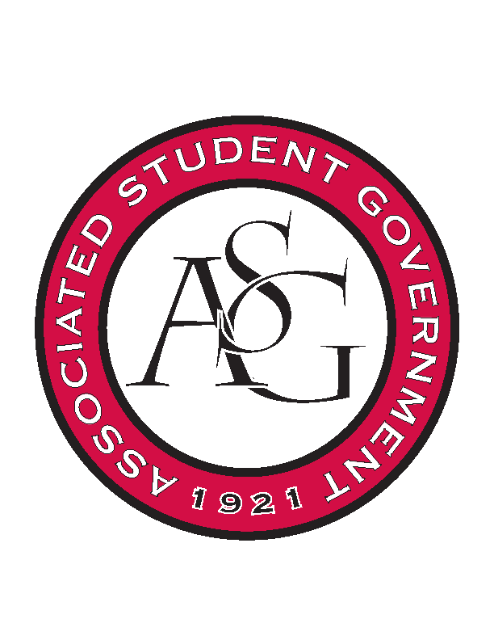
Associated Student Government

Executive Council Meeting

Monday, November 6, 2017 | 12:00 p.m.

- Call To Order
- Roll Call
- Approval of Minutes
- Approval of Agenda
- Special Orders
  - Advisor’s Report
    - Weekly Update
      - Safety Quiz after meeting
      - GSC successful conference
        - 2018 national conference host bid
        - 2017 south central region member of the year
          - eligible for national member of the year
        - won national member of the year as well
      - Cory’s last formal week as Chief
        - Voting at 5:00 on Wednesday for next Chief Justice
      - Brunch at Jody’s house
        - December 2nd (morning time)
      - From Senate
        - Legislative workshop tomorrow 12:00 to 3:00
        - Drop by if available
      - Homecoming Wrap Up
        - 3,039 total votes
        - no reported ballot issues
  - Office Manger’s Report
    - Jody’s Report
      - Reminder
        - Clean up the office! Let’s get organized.
        - Sign timesheets today
  - Graduate Assistant’s Report
    - Josh
    - Sage
      - None
- Reports and Discussion
  - President’s Report
    - Weekly Update
      - Homecoming
        - Good job! ASG parade participation was a big success
      - Position Legacy
        - Begin thinking about what needs to be included in your position layout for the new constitution committee
      - Homecoming Court Document
        - Evaluation of what occurred this year and changes to make next year; update rules and regulations
  - Vice President’s Report
    - Weekly Update
      - MLK Vigil
        - January 15th
        - Continuing to work on details and organize event
      - End of the Year Party
        - Wednesday at US Pizza won the poll
        - Before finals week
  - Treasurer’s Report
  - Secretary’s Report
    - Weekly Update
      - Winter Merchandise
        - B-Unlimited is sending us the mock ups, hopefully have by Wednesday for order forms to go out next week
        - Looking at stickers or hats for holiday gift
      - Weekly Emails
        - So far very successful! Keep sending me information you want included
      - Pictures
        - Working on getting all of the pictures from this weekend onto Facebook and our website
      - OFA Funding Session
        - November 8th
  - GSC Speaker’s Report
    - Weekly Update
  - Chair of the Senate’s Report
    - Weekly Update
  - Chief of Staff’s Report
    - Cabinet
      - Rollin with the Razorbacks
        - This weekend
      - Red Talk
        - November 30th
      - RAG trip
        - November 29th and 30th
      - Parking and Transit
        - Want to send out a poll about student thoughts on new parking system
  - Chief Justice’s Report
  - FLF Coordinator’s Report
- Announcements
  - GSC research panel discussion
    - For undergrads interested in grad school
    - November 16th 5:30- 7:30
    - In Grad Ed Auditorium
  - OFA Standing rules
    - Meeting this week
- Adjournment

