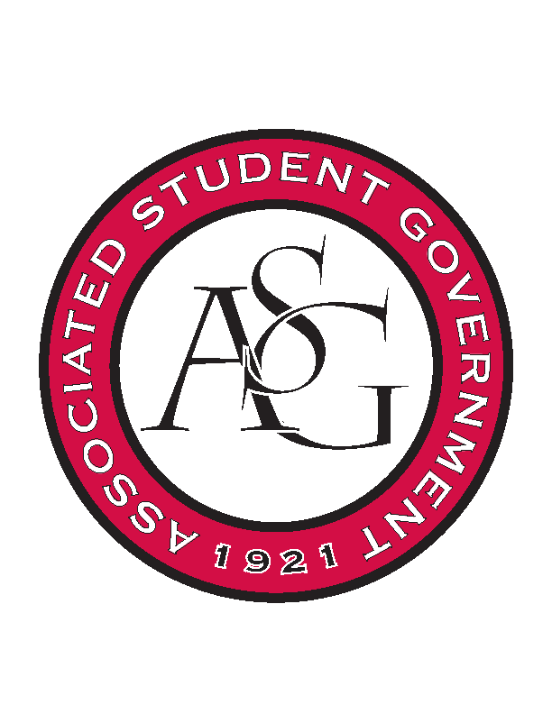
Associated Student Government

ASG Leadership Meeting

Monday December 7th, 2015 | 12:30 p.m.

- Call To Order
- Roll Call
- Special Orders
  - ASG Advisor’s Report
    - Spring Retreat
      - Think it would be good to pick a day in the spring before classes start to regroup and plan out the semester.
      - Couple of hours. One date is after the MLK Vigil – Monday 18th.
    - MLK Vigil
      - Update. Morgan will give it to her in her report.
    - Union Shutdown Preparation
      - Remember to take anything you need out of the office. Make sure offices are ready to be closed for a month.
- Reports and Discussion
  - President’s Report
    - Volleyball Letter
      - Some concerns relating to the team.
      - Reach out to Jeff Long to see what is being done.
    - SDLC
      - Ray and I have been working on the proposal for the Student Diversity Leadership Council
      - Next semester to discuss campus climate
      - Meeting with Dr. Robinson and Dean Harwood Rom for ideas on who to include etc.
      - If you have any organizations that you feel should be included please let us know. We want to have everyone included but make sure it is exclusive in order to be effective.
      - Students Only
    - Meeting’s for the Week
      - Last meeting with Chancellor Ferritor. Let me know if you want me to say anything.
      - Meeting with Chris Wyrick on Thursday at 3:30PM.
    - Student Poll
      - Kyle has not received questions from the Exec. Team.
      - I will send you the questions so far and if you see anything we need to add let me know.
      - Aiming to get 50 questions. Need good PR for students to answer the questions.
  - Vice President’s Report
    - Superlatives
      - Nominations and choosing.
    - MLK Tentative Program
      - I have the MLK tentative program right now.
      - We will have a video of some sort.
      - Reagan will be the MC. Dr. Robinson will give the welcome and Tanner will give the Convocation
      - Keynote Address will be by Joe who is the President of the Black Graduate Student Association
      - Poet and inspirational choir
      - Starts at noon. Let me know if you can’t be there.
    - Committee Appointments
      - Have a committee that is no longer in existence and so I am working on getting them shifted. We will work to get approvals at the first meetings.
      - Open applications when we get back to school.
  - Secretary’s Report
    - New Exec. Time
    - Questions for Traveler
  - Chief of Staff’s Report
    - LR9 Speaker
      - ASG will not be funding – Student Affairs will be funding the $5000.
      - Madeline wants to include ASG with promotion.
      - Meeting with Mary regarding programming. Most likely will be Feb. 11th.
    - Next Semester Events
      - Calendar Invite to be sent.
      - January 29th – Lunch with Veterans
      - RED Talks: Feb 4th: Black History Month. March 3rd: Student Issue Related. March 31st: Student Research. April: TBD
      - Read it and Weep: Feb 8-12
      - Health Week: Last week of March or first week of April
      - Sustainability week: April 18-22 because 22nd is earth day
      - Coffee and Cookie is this Sunday 9-1:00AM
        - Myphones will be there
  - GSC Speaker’s Report
    - GSC Meeting
      - Legislation
        - Meeting Thursday Night
        - Asking for out of state tuition scholarships
        - Commend Interim Chancellor Ferritor
        - Welcome New Chancellor Steinmetz
        - Transfer of Law from Senate to GSC
        - Scholarship for Veterans
    - NAGPS SCRC 15-18 April
      - We may or may not be hosting the conference.
  - Freshman Leadership Forum Coordinator’s Report
    - Midterm Report
      - Really successful semester – Senate simulation, resume workshop and presidents panel
      - Four meetings before the big event and two after
      - I would like exec to come and do an exec panel before the end of the program
    - Big Event Details
      - 5k. March 5th. Women’s empowerment. Pi Phi gate. We are getting sponsorship etc.
    - Next Semester Office Hours
    - Recommendations
      - Let me know
  - Chief Justice’s Report
    - Elections
    - Elections Timeline
      - See timeline.
      - With as many tickets as we have – even if it snows we will still have debates.
    - Elections Commissioner
      - Will be either Kim or Cody.
    - Expenditure Report
      - Five or less receipts you can scan and put it online.
      - Don’t have to put it in code and constitution
    - Qualtrics
      - We aren’t going to be able to have it by vacancy
- Announcements
- Adjournment

