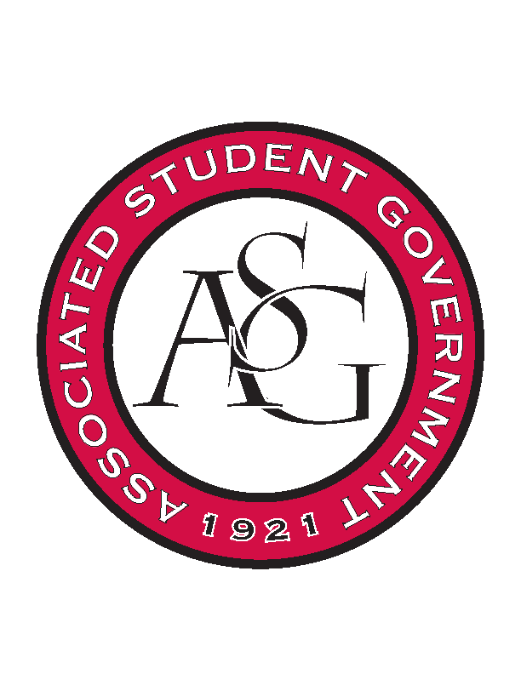
Associated Student Government

ASG Executive Council Meeting

Monday, February 8th, 2016 | 11:00 a.m.

- Call To Order
- Roll Call
- Approval of Minutes
- Special Orders
  - ASG Advisor’s Report
    - Constitution and Code Updates
      - I never mentioned a follow up but over the break one of my side projects was reading the constitution: there’s a fair chunk of changes that need to be made: both minor and major. If we could take that on as a team to review the constitution to make those changes.
    - General Election Prep/Etiquette
      - It is coming up so there is a lot of prep that will happen such as testing the ballot and stuff. For executive officers make sure you keep the advice unbias etc. Election should not be discussed in the office.
      - Jenna: Be aware that you cannot support just one ticket.
    - February All Call
      - It’s in two weeks.
  - ASG Office Manager’s Report
    - Come in and sign the time sheets
- Reports and Discussion
  - President’s Report
    - SEC in DC
      - February 28th – March 1st
      - Finalizing the exact costs
    - Chancellor Meetings
      - I got monthly meetings with the Chancellor set up
      - I will be brining in Scout along to at least one to discuss graduate issues
    - PAB
      - February 19th at 3:00PM for spring supplementary funding.
  - Secretary’s Report
    - Read it and Reap Week
  - Chief of Staff’s Report
    - Cabinet Appointments
      - Andrew Bridges is the new Director of Academic Affairs
      - Jase Rapert is the new Director of Transit and Parking
    - Important Dates
      - Pizza Wars – March 1st
      - RED Talk – March 3rd
      - Health week – March 28th- April 1st
      - RED Talk – March 31st
      - Sustainability week – April 18 – April 22
      - RED Talk – April 21st
      - Don’t have a date for Meal Donation Program yet – Week long program
    - Read it and Reap Week
    - Leaving Tomorrow
      - I’m leaving tomorrow until Monday
  - Chair of Senate’s Report - absent
    - CAPS Speaker for March 29th All Call
    - Senate Clickers
    - Ask ASG Day
    - Legislative Briefing for 2.09.16
    - Arbitration for Grade Forgiveness Bill
    - Inauguration of Vacancy Senators
- Announcements
  - Creed Week
    - Small campaign – Say Yes to this Referendum
      - Promotion video and items
      - Tabling space reserved
      - And promotion at debates
- Adjournment

