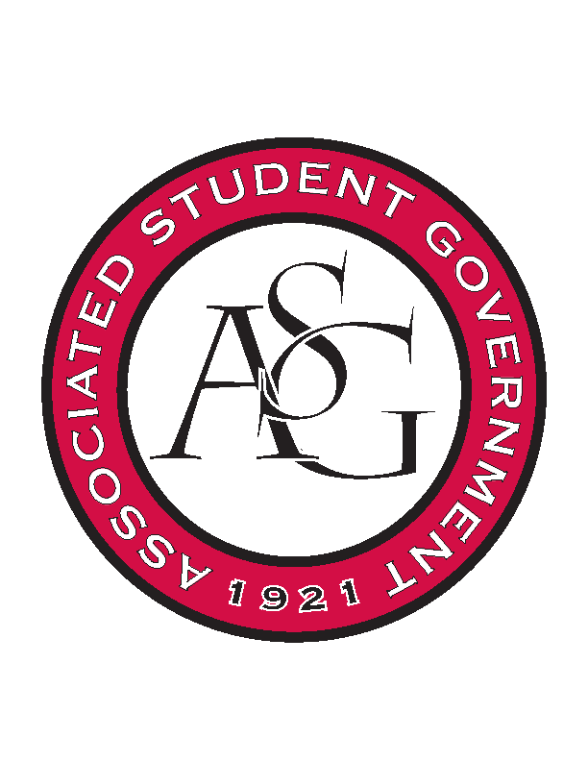
Associated Student Government

ASG Executive Council Meeting

Monday, February 15th, 2016 | 11:00 a.m.

- Call To Order
- Roll Call
- Approval of Minutes
- Special Orders
  - NSSE, Alice Griffin’s Report
    - National Survey of Student Engagement this Spring
      - Need help getting the word out – Freshman and Seniors
      - Take a snapshot of where our freshman are and where our seniors are
      - Without feedback we only have outdate information
      - Designed to improve retention and graduation rates
      - How are students being engaged in educationally purposeful ways
      - Campus administered the survey
      - Turnaround for use of data
        - Get the report in august – see “meaningful change” junior year
      - What was the response rate in 2013?
        - The results are on the institution of research website
        - Freshman response rate was 23% and senior response rate was 30%
      - 38 questions but within each question there can be anywhere from 3-10 sub-questions
  - ASG Office Manager’s Report
- Reports and Discussion
  - Vice President’s Report
    - Campus Closet Challenge
      - I contacted Kiwana’s of Springdale
        - Date should be posted soon
      - Have a pre-drafted letter that explains campus closet
      - Asking everyone on leadership to bring one male and female suit
        - March 7th
      - I had scheduled a meeting with Brock and he didn’t show up
    - Faculty Appreciation Banquet
      - SAB has pulled out of sponsorship
        - We are now close to $2000 short
    - Creed Week
      - Week right before elections start 8-10th
      - Taylor is working on a graphic to circulate
      - Going to need volunteers
      - Talked to Danny about doing a video
  - Treasurer’s Report
    - OFA Update
      - We have a little over 91,000 to allocate
      - To date we have approved 118,000
  - Chair of the Senate’s Report
    - Legislative Briefing
      - We have one piece of legislation proposed by Senator Sims
        - For sustainability week
    - ASG All Call
      - 25 pizza’s, ASG we will be providing drinks
    - Remaining Senate Budget
      - Around 6,000 left in the budget
- Announcements
- Adjournment

