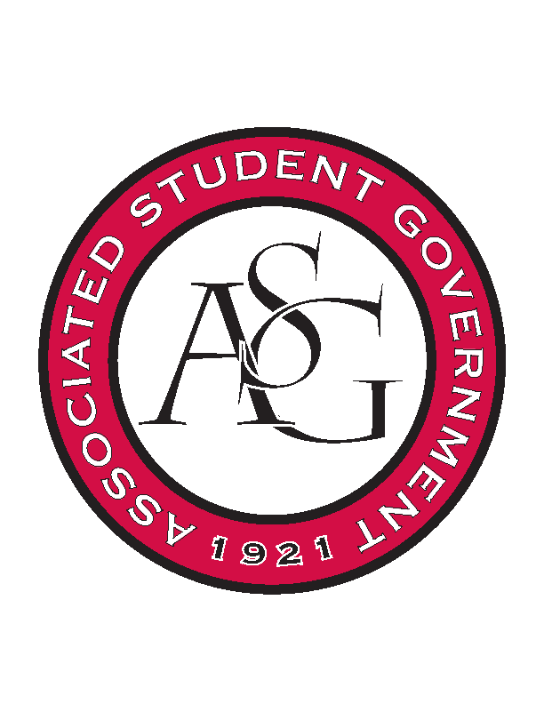
Associated Student Government

ASG Executive Council Meeting

Monday, January 25th, 2015 | 11:00 a.m.

- Call To Order
- Roll Call
- Approval of Minutes
- Special Orders
  - ASG Advisor’s Report
    - Readership Logo
      - Over the summer we asked to come up with a new logo.
      - Current one not in compliance with the trademark rules
      - They didn’t redesign the logo and they just took off the steam and it meet compliance
      - Do we want to use the compliance logo or do we want to redesign the logo completely?
      - If you have a preference then let me know – Keep It.
    - Mid-Year Reports
      - Remember those are due today.
  - ASG GA’s Report
    - Webmaster Projects this Semester
    - Potential Dinner with the Chancellor
      - February 22nd at 6:30PM
    - Professional Development Events Survey
      - Want one in February, March and April
      - Make hard copies and pass them out in meetings
  - ASG Office Manager’s Report
    - Update on Copying Costs
      - In December for allocations we have 575 for printing for that code. Some of the budgets will need to be adjusted.
      - Printing in Meera’s office v. using the other one
    - Memorial Fund
      - We had an account for a memorial fund – death of students.
      - The last two years we get notices after death occurred vs. previous to when we can send flowers etc.
      - There is a memorial event and we could co sponsor that event
        - Usually in April – something we could do to enhance that program.
- Reports and Discussion
  - President’s Report
    - SEC in DC
      - I mentioned last week about it – similar to SEC Exchange but we will also meet with officials
      - Will get costs associated with that within the next couple of days
      - Ranging from sending from 2-6 people
    - SDLC
      - They wrote an article in the Traveler about it
      - Concept is there but need more direction with specifically who should be on there
      - We could invite and determine who should be represented and then we could invite them
        - We could also do an application based process
        - Invite people as a steering committee that will come up with a structure
      - Talk to Tanner if you have any other thoughts
    - Chancellor Transition Team
      - I am on the transition team
      - The first meeting is tomorrow – I will report at Exec. with how that is going
  - Vice President’s Report
    - MLK Vigil Recap
      - If anyone has any thoughts about what should be changed at the Vigil let me know
    - Faculty Appreciation Banquet
      - April 8th will be the banquet
      - The process will start a little sooner because of nominations and selection process
  - Treasurer’s Report
    - OFA Standing Rules Edits
      - We did standing rules before the break
        - Added a line saying that no budgets will be accepted after April 22
        - Requested that RSO’s request pre event consultation meetings and giving amber time to set up that meeting
        - Eliminated a line that said after first round budgets were approved they would be added to the website because it used to be a part of senate but not anymore
        - Added a line that says that non perishable items will then become a part of the office of student activities
        - Added some international guest speaker stuff regarding financing
    - ASG Budget “Cleanup”
      - Need to adjust the budget and reallocate
  - Secretary’s Report
    - Calendar of Events
      - Send me final dates
    - Reminders
  - Chief of Staff’s Report
    - Read it and Reap Week
      - February 8th-12th
      - For the readership program
      - Ryann is putting together gift baskets – there will be golden tickets hidden in the newspapers
      - That Wednesday will be the Morning Chik Fil A pass out
      - Need to promote to ensure the longevity of the program
    - Brunch with Veterans
      - First one is this Friday from 9-10:30 in union 312
      - We are not tweeting about it or anything its supposed to be for veterans on campus and ROTC – promotion internally
    - Legislature Honor Roll
      - Tanner, Scout, Rachel, Thomas and I had our first meeting about it
      - Will have opportunities for public opinion for metrics
    - RED Talks
      - March 3rd – Student Issues
      - March 31st – Student Research
      - April 21st – Sustainability and also other things
    - Grade Forgiveness Act
      - Passed through Senate last semester – written by Director of Academic Affairs
      - Pending the approval from Faculty and Staff Senate
        - May meet Feb. 3rd.
    - Medical Amnesty Act
      - Connor Flocks are putting together powerpoint presentation
      - Tomorrow at cabinet during discussion time they will presenting that
    - Cabinet Dates
    - All Call Dates
      - Need to set all call dates
        - If we do it on a GSC meeting and it is before it will need to be on a Thursday meeting – February 25th at 5:30 Grad Ed.
        - March 29th at 5:45PM
    - Cabinet Applications
  - GSC Speaker’s Report
    - NAGPS Update
      - In person board meeting
      - Have legislative action dates coming up march 12-15
      - Regional Conference at Mizzou April 15th ish – co hosting with the Mid West region
      - Working on the NAGPS institute for like years and it will be coming up this year – different data about when schools do surveys about different things so they can use that data it will be a repository – also a repository for best practices
      - Meeting this Week
        - First meeting this Wednesday
        - Only piece of legislation is the R3 bill – Affiliate program with previous undergrad asg experience can come on
- Announcements
- Adjournment

