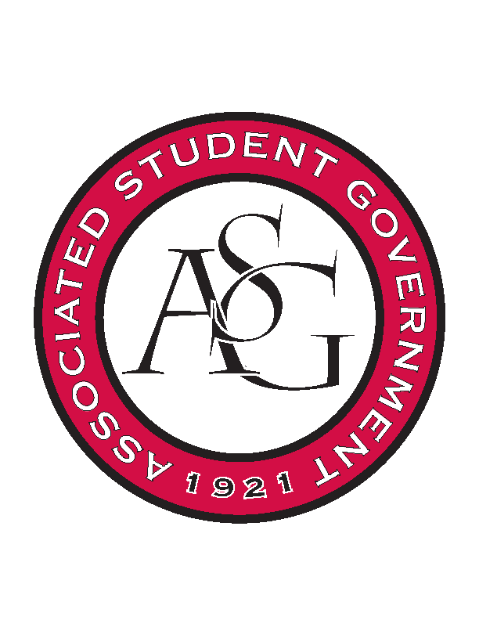
Associated Student Government

ASG Leadership Meeting

Monday, February 1st, 2016 | 11:00 p.m.

- Call To Order
- Roll Call
- Approval of Minutes
- Special Orders
  - ASG Advisor’s Report
    - Master Roster
      - I believe it is mostly updated. Want to make sure that we are updating the original version. Use the version that I attached in the email.
    - Vacancy Election
      - Voting takes place this week – encourage friends to vote.
      - Very competitive for senate
    - All-Call’s
      - Last week we talked about all-call’s.
      - Sticking with Feb. 25th All-Call.
    - PAB Request
      - Tanner has reached out. Want to put it on your radar incase you need funding. Meeting set for last week of February – waiting for responses from members.
  - ASG Office Manager’s Report
- Reports and Discussion
  - President’s Report
    - SDLC

    - Chancellor Transition
    - SEC in DC
  - Vice President’s Report
    - Student Involvement Awards
    - Faculty Appreciation Week/Banquet
    - Creed and Creed Week
    - Committee Applications
    - Graduation Cords and Sashes
  - Secretary’s Report
    - SOOIE Involvement Fair
  - GSC Speaker’s Report
    - Graduation Cords
    - March
  - Chief of Staff’s Report
    - Brunch with Veteran’s Re-Cap
    - Read it and Reap
    - RED Talks
    - Athletics
    - Cabinet Applications
  - Chief Justice Report
    - Elections
    - Justice Appointments
  - Freshman Leadership Forum Coordinator
    - Big Event Update

- Announcements
- Adjournment

