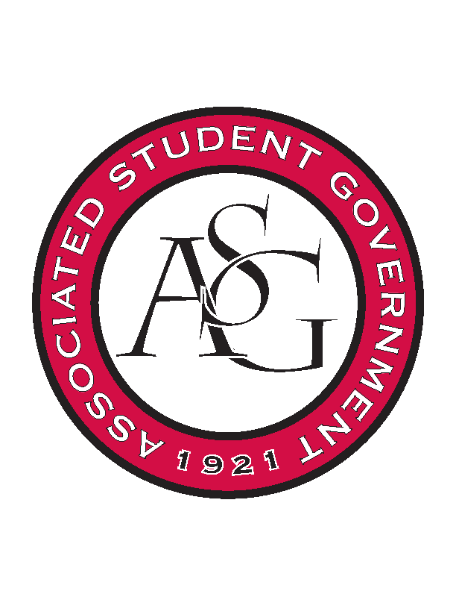
Associated Student Government

ASG Executive Council Meeting

Monday, February 29th, 2016 | 11:00 a.m.

- Call To Order
- Roll Call
- Approval of Minutes
- Special Orders
  - ASG Advisor’s Report
    - ASG Awards for RSO Banquet
      - We need to make sure and take care of the ASG awards that will be given at the banquet
    - Promoting Next All Call
      - Apologize on behalf on the advisors
      - Put a bigger focus on advertising to get more people to the all call
      - CAPS and Pat Walker will be there giving a speech on stress management
      - Tuesday the week after SB
    - Election/Transition Prep
      - Election is happening in two weeks – campaigning and debating will happen next week
      - Keeping the office as a neutral ground
      - Transition Prep will begin in the month of April – three meetings over three weeks
    - Keep Up the Teamwork
  - ASG Office Manager’s Report
    - Jenna will be ordering a sash out of the judicial budget
- Reports and Discussion
  - Treasurer’s Report
    - Vice President’s Updates
      - Campus Closet – 1 Male and 1 Female suit donation by March 7th
        - Internal Drive in office of advancement
        - First rotary meeting went well; will need help going to the next two March 3rd and 9th at 11:45
        - Using the PAB money for general things like racks steamers etc
      - Creed Week
        - Need people to sign up so encourage them to volunteer
      - Faculty Appreciation Banquet
        - April 15th
        - Apps due Friday March 11
  - Chief of Staff’s Report
    - Health Week
      - Week after SB
      - Every day is going to have a different activity
      - Thursday – bouncy houses and inflatables
        - All of the gyms are going to be tabling and passing out promotions
      - Blood Drive on Friday that is hosted by the Red Cross
    - Earth Week
      - Should be finalized latest Monday of next week
      - Third week in April
      - Funding approved by Senate so can move on with reservations
    - Athletics
      - There will be an ASG event for all sports – gymnastics, women’s basketball, tennis (already scheduled), baseball and soccer
    - Pizza Wars
      - Tanner is taking it from Davis
      - Planning it from April
    - RED Talk on Thursday
      - Dr. Robinson
      - Two undocumented students
      - Students with Kids
      - Transgender Community
      - Q&A will be a town hall type of thing
  - Chair of Senate’s Report
    - Legislative Briefing
      - Two new pieces of legislation
        - Legislative Diversity Act of 2016
        - Senators can no longer run on tickets
      - Funding bill – Will Watkins and Pat Walker
        - Creating a psychological decompression room
        - Funding to help furnish this room – ASG can hang a plaque
    - Clicker Update
      - Table it.
    - Vacated Senate Seats
      - Two senators resigned
      - Won’t appoint new senators
- Announcements
- Adjournment

