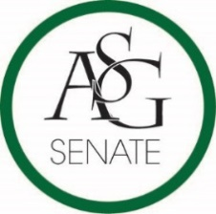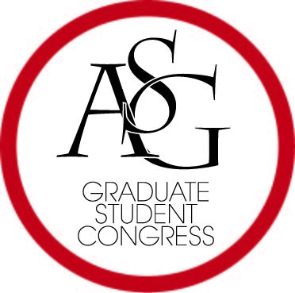**Joint Legislative Session**

Associated Student Government

University of Arkansas

**AGENDA**

**18 September 2016**

**All ASG Retreat**

**Reynolds Center, 2pm**

1. Call to Order
2. Attendance
3. Approve Agenda
4. Special Orders
   1. GSC Advisor Amanda Cantu
   2. ASG Advisor Michael McAllister
5. Old Business
6. New Business
   1. Approve Judicial Appointments, ASG President Connor FLocks
   2. ASG Joint Resolution 2: RESOLUTION TO REQUEST UNIVERSITY OF ARKANSAS GRADUATE COUNCIL AND FACULTY SENATE SUPPORT IN ESTABLISHING A LIFE EVENT AND MEDICAL LEAVE FOR STUDENT ON UNIVERSITY FUNDING
      1. Authors: GSC Speaker Scout Johnson
   3. ASG Joint Bill 1: ASG Joint Resolution 1: RESOLUTION TO REQUEST UNIVERSITY OF ARKANSAS SUPPORT IN CONDEMNING SYMBOLS OF DIVISIVENESS AT THE BIKES, BLUES, AND BBQ RALLY
      1. Authors: GSC Speaker Scout Johnson, GSC Representative Alex Marino, Senator JP Gairhan, Student Joseph Daniels
7. Public Comment (10 Minutes)—reserved for those who do not have speaking privileges on the floor
8. Announcements—Reserved for those who do have speaking privileges on the floor
9. Adjourn