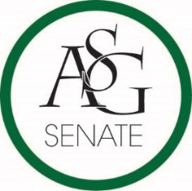

Senate Agenda

November 15th , 2016

Willard J. Walker Hall Room 427, 6:00 PM

1. **Call to Order**
2. **Roll Call**
3. **Approval of the Minutes**
4. **Special Orders**
   1. Reports (5 minutes each)
      1. Special Reports
      2. Advisor, Michael McAllister
      3. Graduate Assistants, Katherine Selman and Katie Martens
      4. President, Connor Flocks
      5. Vice-President, Maggie Benton
      6. Treasurer, Shelby Cormack
      7. Secretary, Jase Rapert
      8. Chief Justice, Cory English
      9. GSC Speaker, Scout Johnson
      10. Cabinet Reports
          1. Chief of Staff, Taylor Farr
      11. FLF Coordinator, Kyle Ward
      12. Chair of the Senate, Will Watkins
      13. Campus Life Report, ASG Senate Bill No. 3
          1. Drew Dorsey
5. **Appointments, Nominations, and Elections**
6. **Public Comment (3 at 2 minutes each)**
7. **Old Business**
   1. ASG Senate Bill No. 3- The Old Main Oath Initiative Funding Bill of 2016
      1. Author(s): ASG Director of Academics Katie Hicks, ASG Director of Academics Jacob Stansell
      2. Sponsor(s): ASG Academic Chair Courtney Brooks, ASG Campus Life Chair Drew Dorsey, ASG Engineering Caucus Chair Parker Fitzgerald, ASG Fulbright Caucus Chair J.P. Gairhan
8. **New Business**
   1. ASG Senate Resolution No. 6- The Safe Ride Operation Expansion Act of 2016
      1. Author(s): Senator Moses Agare, Senator J.P. Gairhan, Zayuris Atencio, Director of Safe Ride Garret Bethel
9. **Announcements**
10. **Adjournment**