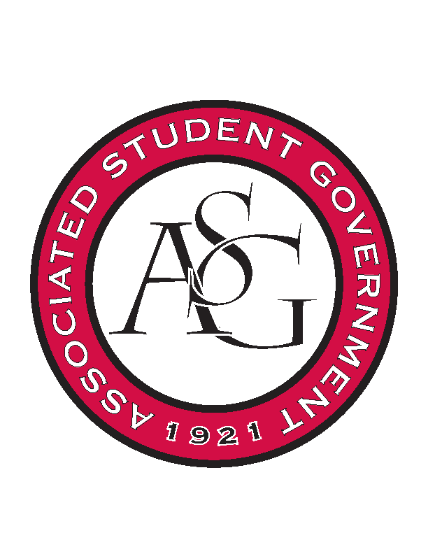
Associated Student Government

Executive Council Meeting

Monday, October 23, 2017 | 12:00 p.m.

- Call To Order
- Roll Call
- Approval of Minutes
- Approval of Agenda
- Special Orders
  - Advisor’s Report
    - Weekly Update
      - Kudos to:
        - Natalie making a grander Chancellor’s Ball a reality.
        - Ashton for executing the social media campaign and giveaway.
      - · The Homecoming Election will be next week.
        - The ASG and OSA office area will be a campaign-free zone. This is because the OSA office is a polling station where paper ballots are distributed. Please assist in reminding students to no display any campaign materials why they are on the floor.
        - Candidates are restricted to soft campaigning until 12:00am on Thursday 10/26.
      - · Reminder:
        - The ASG Budget Submission Form is on HogSync – this is the starting document for utilizing budget areas for ASG programs and legislative allocations. Purchase requests and requests to use the Walmart or P-card will not be approved if a budget form has not been submitted.
        - If you have not completed the OSA/ASG Leadership Assessment form on HogSync, please do so ASAP.

  - Office Manger’s Report
    - Jody’s Report
      - Timesheets
        - Need to be signed before we leave the meeting
      - Updated budgets passed out
      - Congratulate Trevor
        - First person to submit budget form how it’s supposed to be done. Good job!
  - Graduate Assistant’s Report
    - Josh
      - Tabling downstairs
    - Sage
- Reports and Discussion
  - President’s Report
    - Weekly Update
      - Chancellor’s Ball
        - Good job Ashton and Natalie
        - Huge success, the best we could have done it
        - Congrats to Natalie for making Homecoming Court
      - Know coming up
        - PAB this Wednesday (10/25) 6:00pm
          - Email reminder will be sent out for when budgets are due from Andrew
          - Begin discussing what GSC funding will look like
          - Second supplemental session
        - Currently writing a bill to start a committee to rewrite the ASG Code and Constitution
          - Senate must approve bill, then two cabinet members will be chosen, two people from senate, one from OFA, one FLF member, and two at large students
            - Members need to self-nominate and meet the following qualifications:
              - Not running for exec next year
              - Have read the Code and Constitution
              - Flexible meeting times
        - Writing grade forgiveness expansion
          - Talked with Chancellor and Trevor, RAG are going to do an Honor Roll this year
      - Take an ASG member to coffee or lunch this week
  - Vice President’s Report
    - Weekly Update
      - Chancellor’s ball was awesome
        - 900 people attended!
        - Yeti drawing today
      - Meeting with several Senators and the American Heart Association
        - Looking at getting some new vending options on campus
      - Homecoming parade
        - 6:00 on November 3rd and pep rally to follow
      - MLK vigil preparations starting
        - Let Natalie know if you will be back in time
  - Treasurer’s Report
    - Weekly Update
      - Woman’s Leadership Conference
        - Attending tonight
      - PAB Wednesday
      - 5 HogSync applications this week
      - Funding session tomorrow partnering with SOOIE
        - There will be food
  - Secretary’s Report
    - Weekly Update
      - Homecoming certificate reprint
        - Brandon Moritz
      - Camera check out form and graphic request form being created
      - Sweater orders in progress
      - Drawing for Yeti winner today!
  - GSC Speaker’s Report
    - Weekly Update
  - Chair of the Senate’s Report
    - Weekly Update
      - NA
  - Chief of Staff’s Report
    - Cabinet
      - Diversity Week
        - Swing by and visit!
      - Health Days
        - Tuesday and Wednesday
          - Speaker and free health screenings
      - Red Talk
        - November 30th
      - Associate Member Program
        - Had first meeting and set a goal to increase attendance at every meeting, hoping to get 50+ members
      - Put recycling in Greek Housing
        - Greek Life approves, have to convince chapters
      - Starting to work on Earth week
  - Chief Justice’s Report
  - FLF Coordinator’s Report
  - Vice President’s Report
    - Weekly Update
- Announcements
- Adjournment

