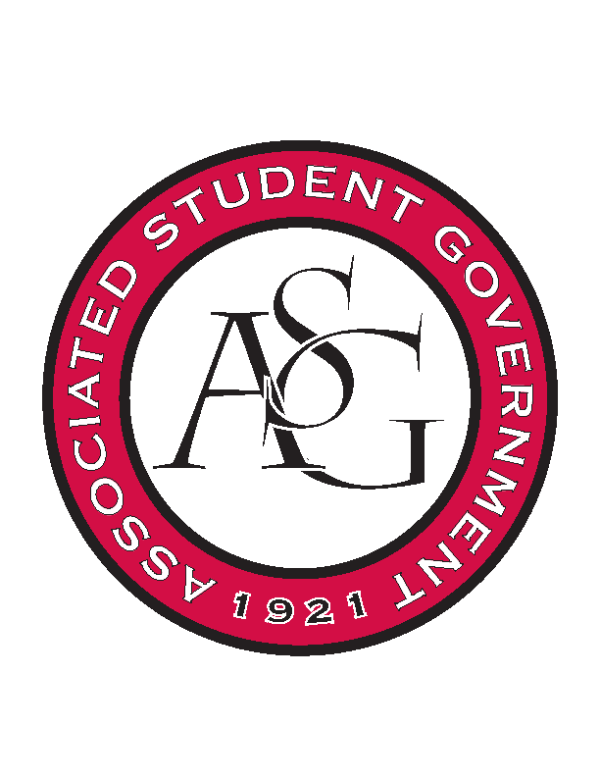
Associated Student Government

ASG Executive Council Meeting

Monday, October 26th, 2015 | 12:30 p.m.

- Call To Order
- Roll Call
- Approval of Minutes
- Special Orders
  - ASG Advisor’s Report
    - Clocking Hours
      - This has been a continued issue – you need to keep up with clocking your hours. It needs to be done accurately. If you need to make a correction then you need to send an email to Rainer and Cody ASAP.
    - Web Pages
      - Keep the website up to date. I will double check today.
    - PAB Request
      - PAB Requests are due this week so that needs to be decided today. What we don’t know needs to wait until next semester.
    - 1:1’s
      - When you have a scheduled 1:1 then please show up for it. If not then please let me know.
    - Camping
      - We cancelled the camping due to thunderstorms. Thoughts on doing camping for Mississippi St. Game
      - We always do it but it will be cold – up for discussion in Cabinet
    - Remaining Semester
      - More than half way. Everyone is doing well. Good work.
      - Double check: Homecoming, Sexual Assault Awareness Day, and State of the Students.
      - Ask ASG Day will be talked about at leadership tomorrow 10/27 – needs to be 14 days in advance for food purposes. (16th/17th of November?)
        - Ask ASG day would be all of ASG – traditionally it was caucus initiative.
      - Banquet – Mid Semester
      - Soccer event: There was a budget request / we will have tents. October 29th – Cookout for the Soccer game against Alabama.
      - Possible Readership event in November but waiting on USA Today.
  - ASG GA’s Report
    - Website
      - Updating the website.
      - For homecoming it has to be Jenna and facilitated through Jamie.
  - ASG Office Manager’s Report
    - Scantron Machines
      - Senate will give that money
- Reports and Discussion
  - President’s Report
    - PAB
      - PAB next Thursday November 5th. Proposals are due this Thursday. I sent the email last week outlining some ideas that I had – Veterans affairs are getting something; not that much. We need to follow up with Rachel Spencer for sustainability (wants to work with UA production). SEC in DC – for RAG, also using money to go to Little Rock in November and we will want more money for them to go to Little Rock in the Spring. President at UCA is interested on doing a summit for leadership in February. RED Talks?
    - State of the Students
      - University of Alabama did theirs in a more public setting. Would it be beneficial to have it in a more public setting than Graduate Building. What about moving the time. Connections Lounge?
      - Will have promo for it. 5:30?
    - Campus Closet
      - We have met with people trying to find a permanent space – we will move forward with the temporary room space – union reservations and storage in the safe ride room. That way if it works we can leverage.
      - Brock needs to start working on local drives etc. PAB funding for racks, etc?
    - 1:1’s
      - I want to start doing 1:1’s with every exec. member once a week. 15 minutes so that I can make sure that I am on top of everything. Email me what time works best for you.
  - Vice President’s Report
    - Homecoming Update
      - Tuesday – Thank a Donor
      - Wednesday – Concert and the pig skin classic
      - Friday – Parade and Pep Rally
      - Saturday – Game day
    - Holiday Party
      - December 8th at 7:00PM. Tuesday. USA Pizza. Next Exec Meeting she will bring a list and we can pick people.
    - MLK Vigil
      - January 18th. Exec needs to be there.
    - FAB Date Set
      - April 8th – Faculty Appreciation Banquet. Friday Evening.
    - Can food Drive
      - Nov 18th – 20th.
  - Secretary’s Report
    - Agenda Items
      - Announcements
    - Sexual Assault Awareness Day
      - Membership encouragement
  - GSC Speaker’s Report
    - Legislation
      - Joint resolutions
        - Mark will be sending them to Jace.
        - Right to Research and recognition of Veteran’s
        - Rachel had to bills – Student Debt Investigation by Greg Leding. We have a number of the debt. But he wants to investigate further – How much per student etc. Nov. 11th Town Hall meeting with Leding (He needs to have an agreement)
    - Chartwells
      - They came and spoke. We brought up healthy food options. Food recovery – more farm to table. Students being able to use food stamp benefits – would be helpful. Talked about pricing – we’re pricing is completely out of line they will be doing competitive bidding.
    - Dual Enrollment Student Issue
      - Law students and NPA students – tuition goes from undergrad, grad, and law. These students are enrolled in both and being charged in the highest for ALL classes no matter the class.
- Announcements
  - Tanner: “Brutal Facts” Nov. 9th
    - First part of the meeting will be business and the last half will be open discussion of where we are and what we have failed at. Healthy to discuss where we have not been successful – everyone come with two failures for your role or organization. Figure out how to better avoid those.
    - Homecoming Review
      - Meeting to review the homecoming process from top to bottom.
      - Application process etc.
    - Student Poll
      - Working with my assistant.
    - Campus Climate
      - Engage in the campus climate and to seek those issues
      - Dr. Dow new committee UA Race Talks – Want help to promote the events and how ASG can help. Talking openingly on the issue
  - Elizabeth:
    - All Call tomorrow
    - Soccer Event Thursday
    - Pat Walker is having Sick or Treat
      - ASG is promoting it
    - Study Break
      - They put us down for the day we requested
      - Would we want to do study packs or stick with cookies and coffee?
        - Stick with cookies and coffee
- Adjournment

