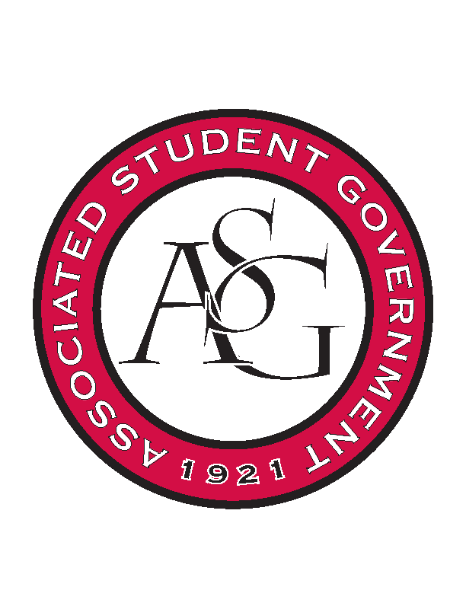
Associated Student Government

ASG Executive Council Meeting

Monday, November 2nd, 2015 | 12:30 p.m.

- Call To Order
- Roll Call
- Approval of Minutes
- Special Orders
  - ASG Office Manager’s Report
- Reports and Discussion
  - President’s Report
    - State of the Students
      - 50-60 for the podium
      - Connections Lounge- waiting for confirmation
      - Senate will occur right after
  - Vice President’s Report
    - Homecoming Review Committee
      - Multiple opinions – form a review committee to go over the process top to bottom
      - Structuring of the committee – One representative from every ASG body
        - Maybe get some of the judges
    - Homecoming 2015 Review
      - If you have suggestions for next year besides the committee
    - Holiday Party – Budget and Superlatives List
      - Maybe pulling money from a different budget to have more food
    - Committee Applications
      - Start promoting it so we can fill all the spots
  - Secretary’s Report
    - Sexual Assault Awareness Day
  - Chief of Staff’s Report
    - Work It Off Program
      - Approved to put the work it off program to the parking tickets
      - Ryals should be meeting with Katherine and Lizzi soon to purchase the promo for the work it off program
    - Razorback Action Group
      - Little Rock this Thursday Evening
        - Higher Ed. Department Head
    - Events Before Thanksgiving
      - 11th of November is the Volleyball game
        - Supposed to be promotions there but might be past the deadline
    - Open Cabinet Position
      - Liaison to off campus and non traditional students
      - Have it up by the 9th and will go down on the 1st of December
  - Chair of Senate’s Report
    - Next Semester All-Call Dates
      - Be thinking of dates for next semester so we can start planning
    - All-Call Review
      - Went pretty decent.
      - Just need help with logistics for the all – call
      - Food starts at 5:30 – All Call Starts at 5:45
        - See if cabinet can meet somewhere in the grad ed building on the days of the All Call
        - Making the All Calls mandatory
    - Possible Law School Switch to GSC
      - Law school is still represented within the senate. Kristina Cole has approached us about moving to the GSC
      - Thought process: Whoever was in charge two years ago - they had concern for the law students if they left senate and went to GSC that that would retaliate their RSO funding.
      - They will have to write legislation and then 2/3 majority then file referendum for judicial and it will have to be approved by the chancellor etc. (They will need to check the proportions – figure that out beforehand and then send up the hierarchy)
  - GSC Speaker’s Report
    - NAGPS National Conference Recap
      - Conference in California
    - New Legislation for GSC
      - Two pieces of legislation coming up
        - GSC Cabinet will meet for first reading – second will be the 18th
        - One is about graduate tuition – trying with one bill is to create an incentive to have people come here for graduate school – tuition tier system based on publications etc.
          - Undergrads currently have access to non – residential tuition waiver bringing that back for grad
          - Undergrad is about to have stair steps for waiver for waiver
      - Creating a more prominent role for the associate member
        - Trying to work on recruiting with ASG experience into GSC because a wealth of institutional knowledge
        - Piece of legislation – automatic role with anyone with ASG experience into GSC
          - Currently they’re all able to run in the fall vacancy
          - Need to see how they would be approved into their position
            - If there were vacancies then GSC would vote
  - Chief Justices’ Report
    - New Legislation for Expense Reports
      - Meeting Wednesday about it
        - Move vacancy and gsc elections etc to electronic
        - Keep Exec and homecoming to how it is because so much money
      - Elections commissioner position open
      - Two Vacant Justice Seats
- Announcements
  - Rainer will not be here next week.
- Adjournment

