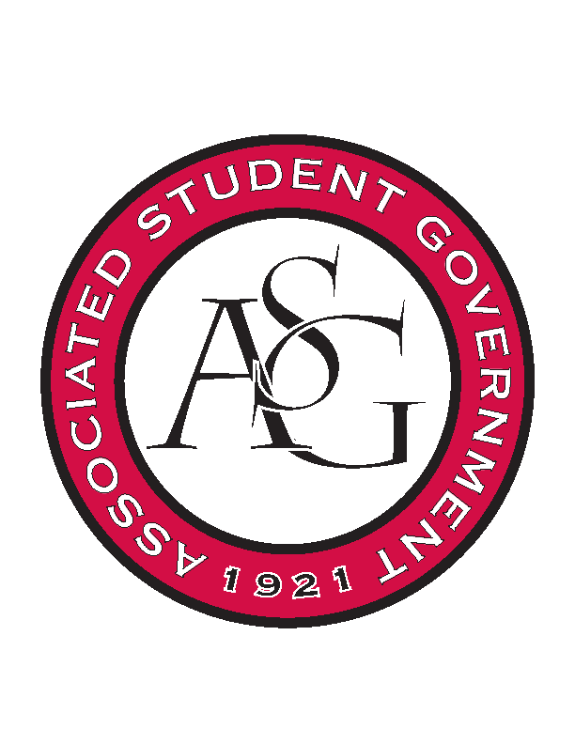
Associated Student Government

ASG Executive Council Meeting

Monday, November 9th, 2015 | 12:30 p.m.

- Call To Order
- Roll Call
- Approval of Minutes
- Special Orders
  - ASG Office Manager’s Report
- Reports and Discussion
  - President’s Report
    - State of the Students
      - Called to follow up on the connections lounge and it has been reserved.
      - Still try to keep in the Union – Theatre, or we can have it in the grad ed building
      - Most effective way would be to have it in the open.
      - Grad Ed. Building
    - Board of Trustees
      - Meeting Nov. 20th at 8:30
      - Invited Morgan and Tanner to watch the campus involvement video
    - New Chancellor
      - Is there anything that we want to do for when he gets here?
      - Lunch or coffee?
      - Make Dr. Robinson Dean Hardwood Rom to the lunch – make it student activities
    - Next Semester
      - Start thinking ahead
      - Conference call with all the student body presidents
        - Focused on diversity inclusion – events going on at Mizzou
  - Treasurer’s Report
    - FOIA
      - Couple of weeks ago. Everything is fine. We are working with community relations – we are handing over everything that was requested.
      - If anyone reaches out to you about this it needs to go straight to Rainer and Community Relations
    - PAB
      - We got our funding. Keep in mind that we have the extra money for events and initiatives.
  - Secretary’s Report
    - Sexual Assault Awareness Day Recap
      - 675 signatures
    - Newswire Reminder
  - Chief of Staff’s Report
    - Cabinet Meeting
      - Tomorrow at 5. Final meeting of the semester is Dec. 1
      - Volleyball game is Nov. 11
      - Dec. 3 Red Talk on research
    - Spring Cabinet Event / Initiative Ideas
      - Tabled.
    - New Standing Rules
      - Changing standing rules to include an absence policy and update for what they are doing next month.
- Announcements
- Adjournment

