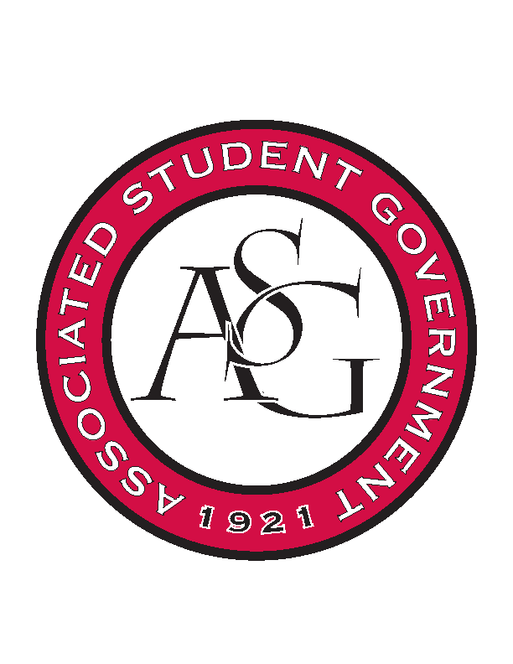**Associated Student Government**

**Office of Financial Affairs Meeting Agenda**

**September 14, 2017**

1. **Call To Order**
2. **Roll Call -5:00 pm**
   1. **Adam Jones**
   2. **Andrew Estes**
   3. **Colin Gonzalez**
      * 1. **Proxy- Madeline**
   4. **Jalen Hemphill**
   5. **Kyle Ward**
   6. **Kadarius**
   7. **Peyton Podschwit**
      * 1. **Proxy- Ploy**
   8. **Semien Hagos**
   9. **Sofia Hadley**

**Proxies**

* 1. **Kate Hedgecock**
  2. **Madeline Brown**
  3. **William Neely**
  4. **Ploy Pleetissamuth**

1. **Approval of the Minutes**
2. **Audit Reports**
3. **Old Business**
   1. **Japanese Students Association**
      * 1. **Second round approved 9-0**
   2. **Technology and Engineering Education Collegiate Association**
      * 1. **Didn’t reply to emails about where to find registration rates**
        2. **Second round denied 8-1**
   3. **Engineering Safety**
      * 1. **Second round approved 9-0**
   4. **Eta Sigma Phi Beta Chapter**
      * 1. **Second round approved 6-3**
4. **New Business**
   1. **Society for Women Engineering**
      * 1. **First round approved 9-0**
   2. **Spoon University Recruitment**
      * 1. **Tell them about mandatory advertising**
        2. **First round approved 7-2**
   3. **Spoon University Event**
      * 1. **Board doesn’t find this educational**
        2. **First round denied 9-0**
   4. **Lambda Alpha Epsilon**
      * 1. **Will there be a monetary award?**
        2. **First round approved 9-0**
   5. **Razorback Booster Club Auburn**
      * 1. **What is the honorarium for?**
        2. **Not educational**
        3. **Denied 5-4**
   6. **Razorback Booster Club Homecoming**
      * 1. **Denied 5-4**
   7. **Caribbean Students Association**
      * 1. **What’s the labor fee?**
        2. **How will you educate students at this event?**
        3. **On some food items- are they boxes?**
        4. **Approved 9-0**
   8. **Simple Truth**
      * 1. **First round approved 9-0**
   9. **National Association for Music Education**
      * 1. **Approved 9-0**
   10. **Business Law Society**
       * 1. **First round approved 9-0**
5. **Announcements**
   1. **ASG Retreat September 17 12:30 – 4:00 pm**
6. ***Adjournment*** 
   1. ***5:50pm***