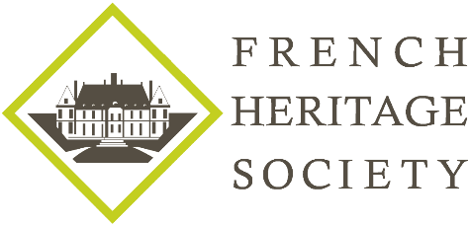

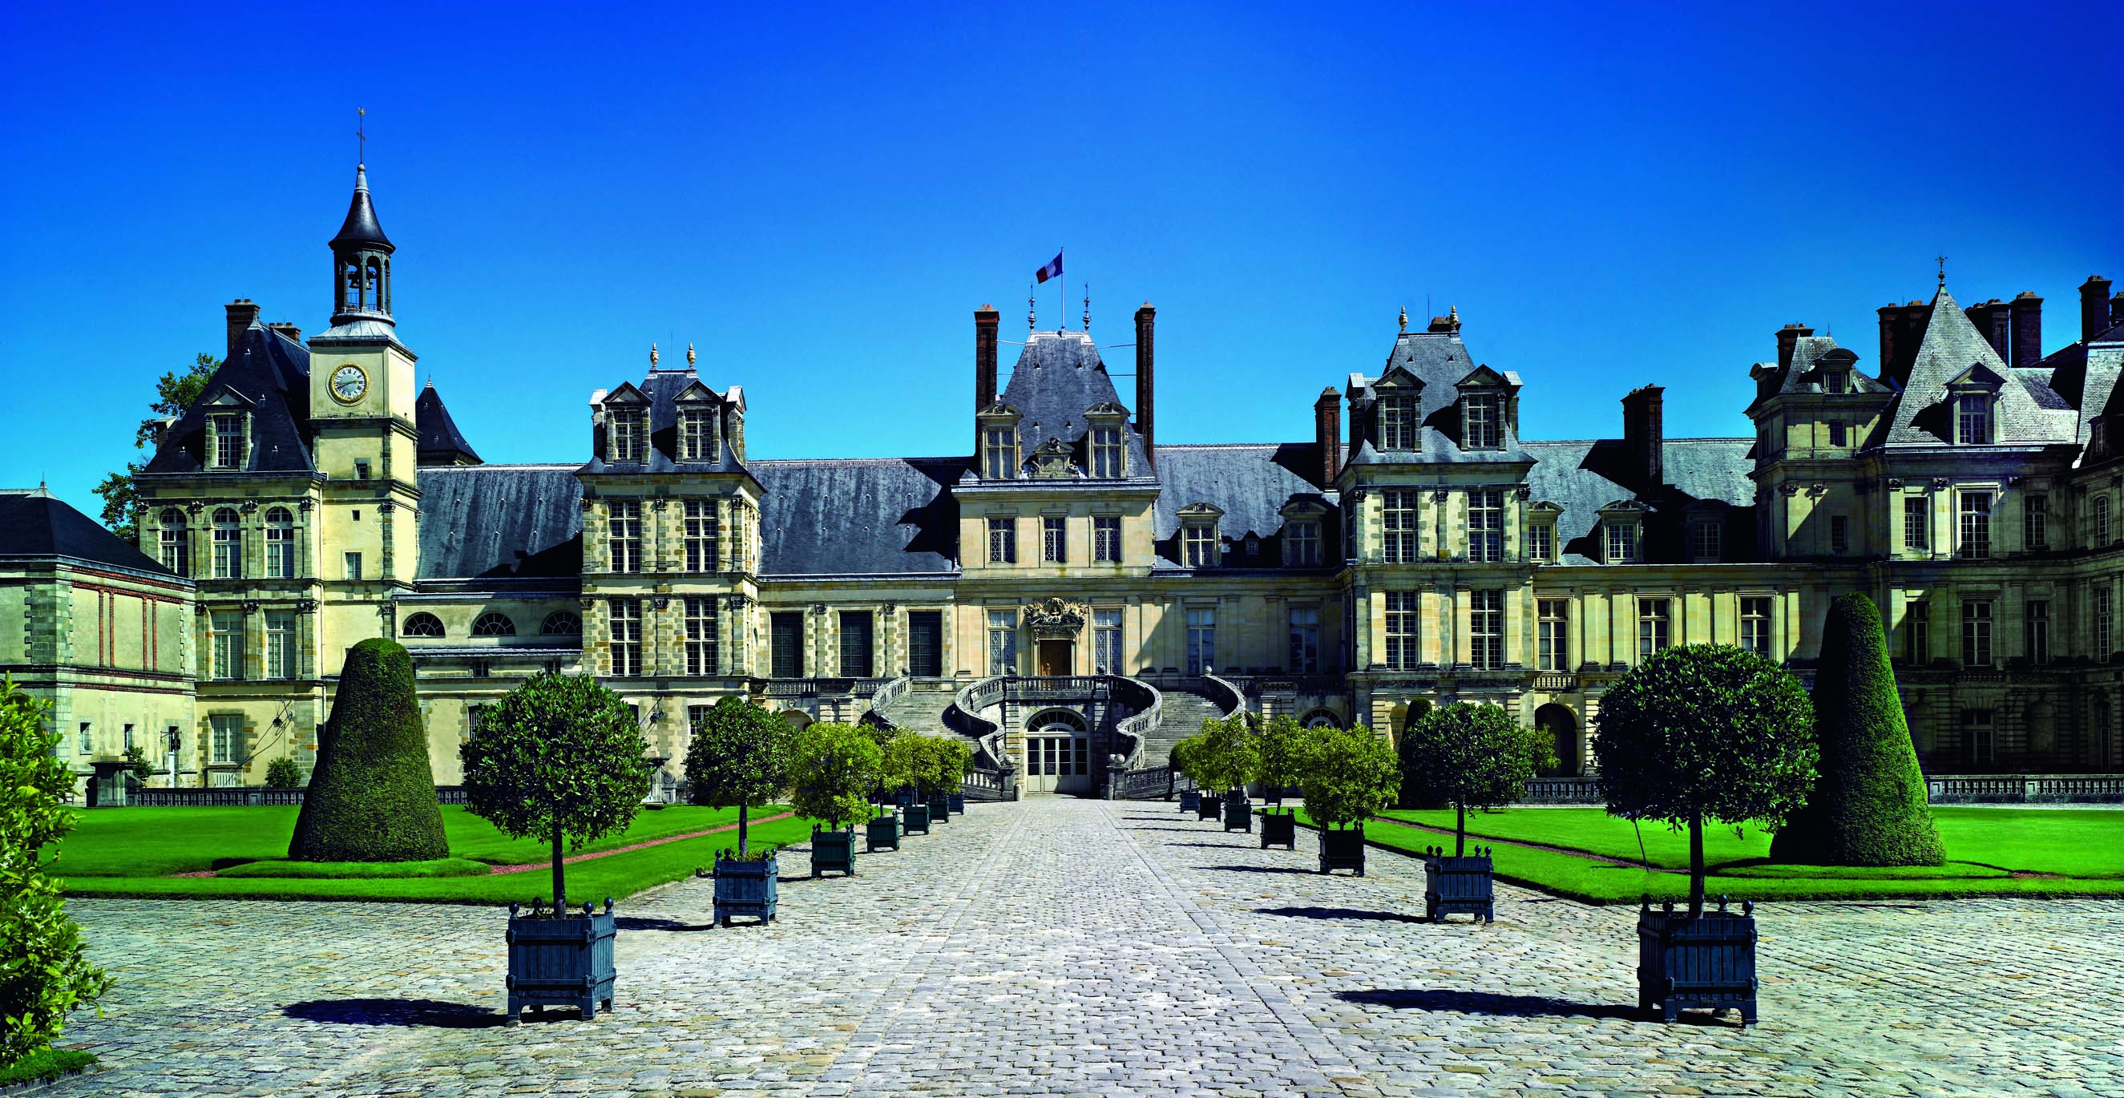

FRENCH HERITAGE SOCIETY- SUMMER 2018
CHÂTEAU DE FONTAINEBLEAU

ORGANIZATION:
French Heritage Society
7 rue Lincoln - 75008 Paris
01 40 70 07 57

CONTACT PERSONS :
Diane de Roquette-Buisson and Amy Fienga – Chairmen
students@frenchheritagesociety.org
Inès Sauzet-Fontanel – Event and Development Officer ines@frenchheritagesociety.org

PURPOSE: The purpose of this internship is to provide mature art history/marketing and communication students with an in-depth perspective of the day-to-day marketing and communication duties at the château. The successful candidate will have an opportunity to work directly with the marketing and communication director as well as a team of interns to reflect on the château’s e-profile, marketing strategies, events, sponsorship programs and harmonization of written communication tools. Also tour guide responsibilities and participation in VIP events may be required.
__________________________________________________________________

QUALIFICATIONS: Marketing and communication/art history major, minimum junior

LANGUAGE REQUIREMENTS: Strong command of French and third language a plus (Spanish, Italian, Arabic, Mandarin)
__________________________________________________________________

APPROXIMATE DATES : July 2018, 4 weeks

INTERNSHIP LOCATION : Château de Fontainebleau, Fontainebleau, France
__________________________________________________________________

HOUSING/MEALS: not included

STIPEND: $2000

VISA: no visa - valid American passport

INSURANCE: Medical insurance and civil liability provided by the student
__________________________________________________________________

APPLICATION DEADLINE: February 15th, 2018
Apply at students@frencheritagesociety.org

