

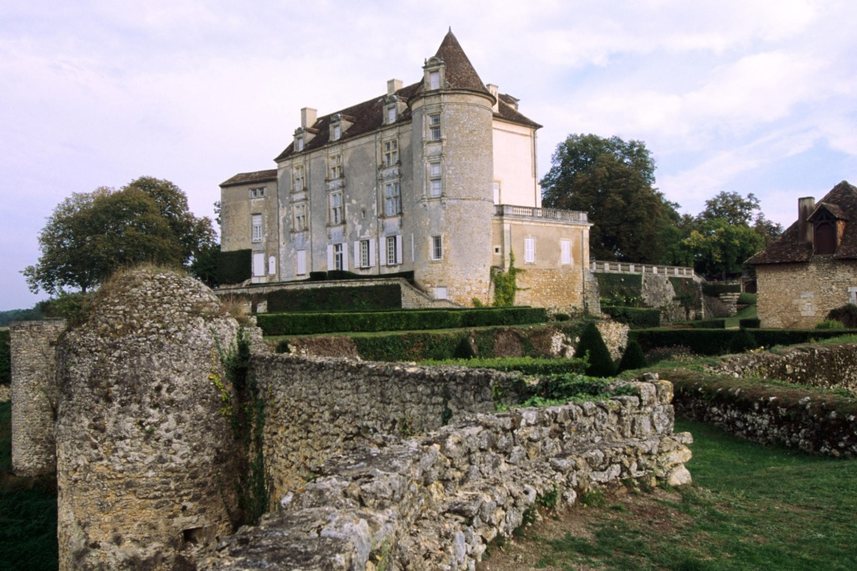

FRENCH HERITAGE SOCIETY- SUMMER 2018
CHÂTEAUX STAY CIRCUIT

ORGANIZATION:
French Heritage Society
7 rue Lincoln - 75008 Paris
01 40 70 07 57

CONTACT PERSONS :
Diane de Roquette-Buisson and Amy Fienga – Chairmen
students@frenchheritagesociety.org
Inès Sauzet-Fontanel – Event and Development Officer ines@frenchheritagesociety.org

PURPOSE: The purpose of this château stay circuit is to provide mature art history students with a « taster » of understanding heritage management and gaining an appreciation for preservation techniques. The successful candidate will have an opportunity to observe and work closely with the proprietors and staff in a variety of tasks including tour guide, research, translations, participation in special events and observation of ongoing restauration work.
__________________________________________________________________

QUALIFICATIONS: Art history student with an interest in French heritage and history

LANGUAGE REQUIREMENTS: Good knowledge of French and third language a plus (Spanish, Italian, Mandarin, Japanese)
__________________________________________________________________

APPROXIMATE DATES: June to August 2018, 6 weeks

INTERNSHIP LOCATION: Châteaux stay circuit, hands-on-experience working closely with the châteaux proprietors, getting a glimpse of business and marketing aspects of a family-owned and run historic French monument, with tour guide and marketing/communication responsibilities. Among the referenced locations are: Château de Montréal (Dordogne), Château de Gizeux (Indre-et-Loire), Château de Commarque (Dordogne).
__________________________________________________________________

HOUSING/MEALS: possibilities are available on site, to be organized directly with the Châteaux*.

STIPEND: $2000

VISA: no visa - valid American passport

INSURANCE: Medical insurance and civil liability provided by the student
__________________________________________________________________

APPLICATION DEADLINE: February 15th, 2018
Apply at students@frencheritagesociety.org

* FHS does not intervene in the logistics of housing/meal.

