

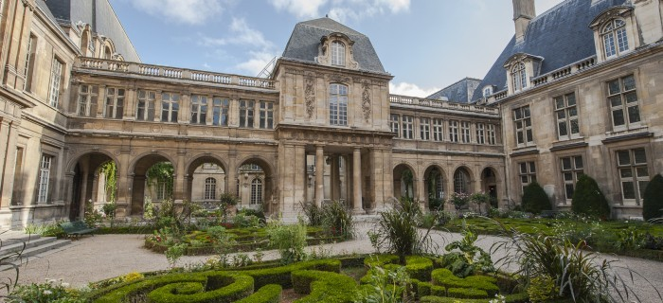
FRENCH HERITAGE SOCIETY - SUMMER 2018
CARNAVALET MUSEUM

ORGANIZATION:
French Heritage Society
7 rue Lincoln - 75008 Paris
01 40 70 07 57

CONTACT PERSONS :
Diane de Roquette-Buisson and Amy Fienga – Chairmen
students@frenchheritagesociety.org
Inès Sauzet-Fontanel – Event and Development Officer ines@frenchheritagesociety.org

PURPOSE: The purpose of this internship is to provide mature art history students who intend on pursuing a career in curation with an in-depth understanding of the complexities and decision-making process of the Carnavalet Museum, which is currently undergoing major renovation for a re-opening in 2019. The successful candidate will have an opportunity to work closely with the museum’s librarian including parsing through archives and files, cataloguing and researching and participate in the organization of a presentation of the renovation project to private patrons in the United States.
_______________________________________________________________

QUALIFICATIONS: Art history/curatorial masters or PhD student with strong knowledge of French heritage and history

LANGUAGE REQUIREMENTS: Strong command of French and third language a plus
__________________________________________________________________

APPROXIMATE DATES: June/July 2018, 4 weeks minimum

INTERNSHIP LOCATION: Carnavalet Museum – Temporary offices (Paris 18e)
__________________________________________________________________

HOUSING/MEALS: not included

STIPEND: $2000

VISA: no visa - valid American passport

INSURANCE: Medical insurance and civil liability provided by the student
__________________________________________________________________

APPLICATION DEADLINE: February 15th, 2018
Apply at students@frencheritagesociety.org

