

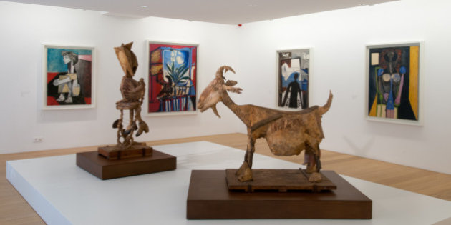

FRENCH HERITAGE SOCIETY- SUMMER 2018
PICASSO MUSEUM

ORGANIZATION:
French Heritage Society
7 rue Lincoln - 75008 Paris
01 40 70 07 57

CONTACT PERSONS :
Diane de Roquette-Buisson and Amy Fienga – Chairmen
students@frenchheritagesociety.org
Inès Sauzet-Fontanel – Event and Development Officer ines@frenchheritagesociety.org

PURPOSE: The purpose of this internship is to provide mature art history/marketing and communication students with an in-depth perspective of the day-to-day duties at the museum and observe how integrated America and France are within the marketing and communications department. The successful candidate will have an opportunity to work directly with the marketing and communication director as well as interfacing with the curator. Among the duties are translation of marketing and communication tools, press events and participating in the museum’s benefactor programs.
__________________________________________________________________

QUALIFICATIONS: Marketing and communication/art history major, minimum junior

LANGUAGE REQUIREMENTS: Strong command of French and third language a plus (Spanish)
__________________________________________________________________

APPROXIMATE DATES: June/July 2018, 4 weeks minimum

INTERNSHIP LOCATION: Picasso Museum, Paris, France
__________________________________________________________________

HOUSING/MEALS: not included

STIPEND: $2000

VISA: no visa - valid American passport

INSURANCE: Medical insurance and civil liability provided by the student
__________________________________________________________________

APPLICATION DEADLINE: February 15th, 2018
Apply at students@frencheritagesociety.org

