

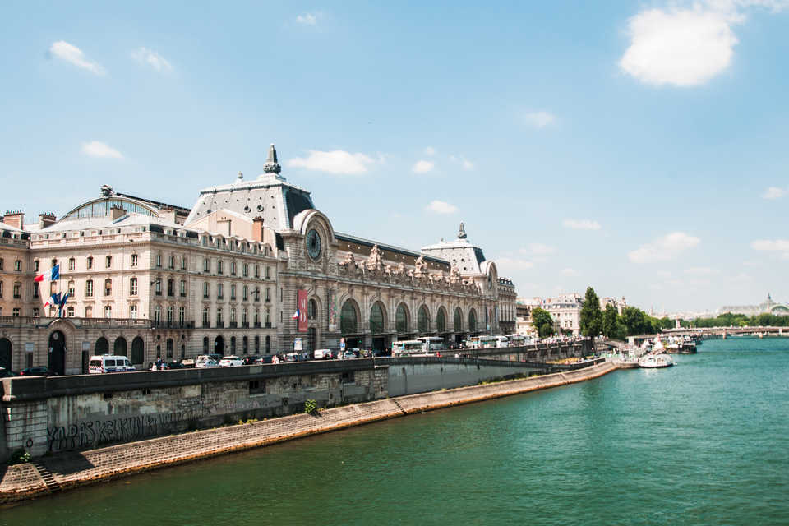

FRENCH HERITAGE SOCIETY - SUMMER 2018
ORSAY MUSEUM

ORGANIZATION:
French Heritage Society
7 rue Lincoln - 75008 Paris
01 40 70 07 57

CONTACT PERSONS :
Diane de Roquette-Buisson and Amy Fienga – Chairmen
students@frenchheritagesociety.org
Inès Sauzet-Fontanel – Event and Development Officer ines@frenchheritagesociety.org

PURPOSE: The purpose of this internship is to provide mature art history students who intend on pursuing a career in curation with an in-depth understanding of the tasks linked to contributing to temporary exhibits, the communication strategies linked to the museum’s mission and general curatorial challenges which are part of a typical day in a life of a museum. The successful candidate will have an opportunity to participate in curatorial business meetings and work closely with the curator and his staff in a variety of tasks including research, cataloguing, translations, and exhibition preparation.
__________________________________________________________________

QUALIFICATIONS: Art history/curatorial masters or PhD student with strong knowledge of 19th Century Art and especially French painting and art history in general

LANGUAGE REQUIREMENTS: Strong command of French and third language a plus
__________________________________________________________________

APPROXIMATE DATES: June/July 2018, 4 weeks minimum

INTERNSHIP LOCATION: Orsay Museum, Paris, France
__________________________________________________________________

HOUSING/MEALS: not included

STIPEND: $2000

VISA: no visa - valid American passport

INSURANCE: Medical insurance and civil liability provided by the student
__________________________________________________________________

APPLICATION DEADLINE: February 15th, 2018
Apply at students@frencheritagesociety.org

