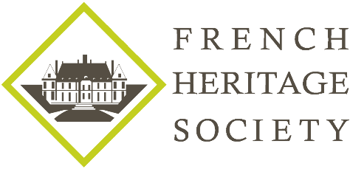

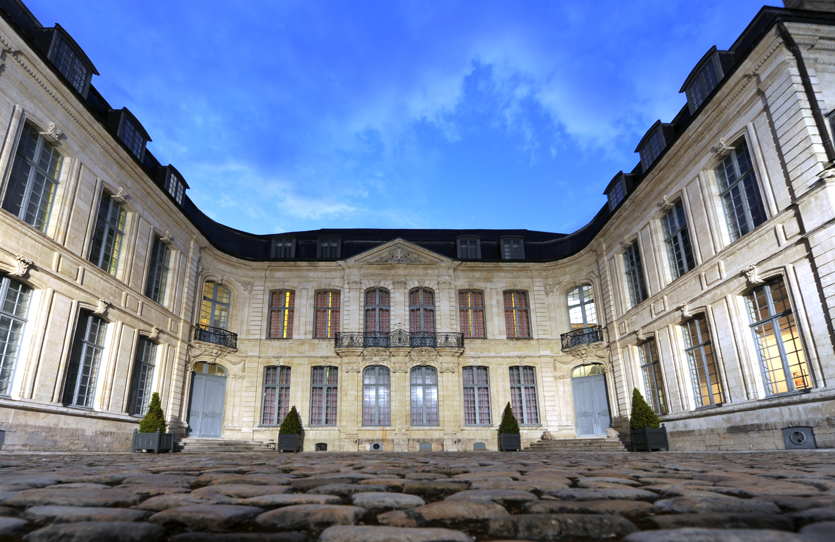

FRENCH HERITAGE SOCIETY- SUMMER 2018
SANDELIN MUSEUM

ORGANIZATION:
French Heritage Society
7 rue Lincoln - 75008 Paris
01 40 70 07 57

CONTACT PERSONS :
Diane de Roquette-Buisson and Amy Fienga – Chairmen
students@frenchheritagesociety.org
Inès Sauzet-Fontanel – Event and Development Officer ines@frenchheritagesociety.org

PURPOSE: The purpose of this internship is translating materials and curating an upcoming exhibition, and working towards the common goal of preserving French heritage and forging a transatlantic cultural bond. The successful candidate will have an opportunity to work directly with the museum’s management to learn more about and provide communication for the common heritage shared between France and the United States due to Saint-Omer’s proud and long history of intercultural friendship.
__________________________________________________________________

QUALIFICATIONS: Marketing and communication/art history major, minimum junior, strong commitment to Franco-American friendship

LANGUAGE REQUIREMENTS: Strong command of French
__________________________________________________________________

APPROXIMATE DATES: June/July 2018, 4 weeks minimum

INTERNSHIP LOCATION: Sandelin Museum, Saint-Omer, France
__________________________________________________________________

HOUSING/MEALS: Housing/meal possibilities are available on site, to be organized directly with the museum*.

STIPEND: $2000

VISA: no visa - valid American passport

INSURANCE: Medical insurance and civil liability provided by the student
__________________________________________________________________

APPLICATION DEADLINE: February 15th, 2018
Apply at students@frencheritagesociety.org

* FHS does not intervene in the logistics of housing/meal.

