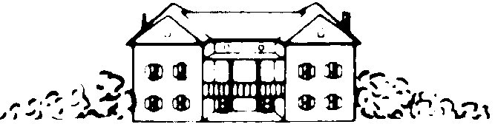

MOUNT VERNON HOTEL MUSEUM & GARDEN

421 East 61st Street, New York, NY 10065

Phone 212.838.6878 Fax 212.838.7390
www.mvhm.org

William Randolph Hearst Fellowship 2018

May 29-July 27, 2018

The Mount Vernon Hotel Museum and Garden (MVHMG) offers two summer Fellowships for undergraduate or graduate students interested in U.S. history, museum studies, museum education, material culture or other related fields. Fellows participate directly in the daily operations of a historic site. Fellows complete original research projects on antebellum NYC that become interpretation resources, conduct tours, and participate in programs for children and adults. Now in its thirty-fourth year, the full-time Fellowship, funded by the William Randolph Hearst Foundation, consists of nine weeks with a $2,750 stipend. Hours are 9AM-5PM Monday-Friday, with occasional evenings for special events. Fellows are responsible for their own housing and transportation.

One of the few surviving Manhattan buildings constructed before 1800, the Museum was constructed as a carriage house on Mount Vernon, a large country estate situated along the East River. In 1826, the building was converted into the Mount Vernon Hotel, a popular country resort for the new middle class seeking to escape the city. Accredited by the American Alliance of Museums (AAM), MVHMG interprets travel, leisure, work and play in antebellum New York and Jacksonian America. The Museum is owned and operated by the Colonial Dames of America, a women’s genealogical organization dedicated to historic preservation.

To apply, complete the application form below and email it with the following additional materials to Education@mvhm.org by Monday, March 12, 2018. Note: Fellows must be enrolled in graduate or undergraduate programs before and after Summer 2018.

- A personal statement of one page (this can be included in your cover letter), detailing your interest in the Fellowship program. Clearly state your professional goals and areas of interest and what skills and abilities you can contribute to the Museum’s work. Discuss the most significant historical work you have read and explain how and why it affected you. Describe your teaching experience. Finally, describe the outcomes you hope the experience will produce.

- Two letters of recommendation from professors or supervisors in a related field

- Current resume or Curriculum vitae

- Writing Sample
William Randolph Hearst Fellowship 2018

May 29-July 27, 2018

CONTACT INFORMATION

Name: __________________________________________________________________Last First Middle

Permanent Address:_________________________________________________ ______
Street_____________________________________________________________________
City State Zip/Postal Code________

Current Address:
________________________________________________________________________
Street_________________________________________________________________

City State Zip/Postal Code_________

Current Telephone: ____________________ Permanent Telephone:____________ _________________

Email Address: _________________________________________________________

EDUCATION

□Undergraduate □Graduate Graduation Date _______

Major Field_______________________________________________________________

Minor Field _________________________________________________________

Thesis Topic and Advisor____________________________________________________________
____________________________________________________________
□Undergraduate □Graduate Graduation Date _______

Major Field_______________________________________________________________

Minor Field _________________________________________________________

Thesis Topic and Advisor____________________________________________________________

REFERENCES

____________________________________________________________________
Name Title Affiliation

____________________________________________________________________
Name Title Affiliation

Application submitted ________________________________________________

Signature of applicant __________________________________________________

