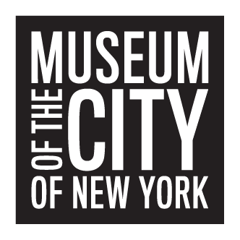

APPLICATION FOR INTERNSHIP

TYPE OF INTERNSHIP ____Spring _____Summer ____Fall

(Please order 1st and 2nd choices)

___Collections ____ Curatorial ___Development ___Education

____Graphic Design ___ Information Technology ____Marketing
____ Public Programs __________________________________Other
Preferred Start Date: ______________________ End Date: ______________________
Preferred Days per week___________________ Hours per day____________________

How did you learn about this internship? ____________________________________

Applicants must submit a cover letter outlining interest in a particular division of the Museum and relevant materials to support their choice(s).

PERSONAL DATA

Name___________________________________________ Date of Birth: ___________

Home Address___________________________________________________________
_______________________________________________________________________
Home Phone________________________ Mobile #____________________________

E-mail address____________________________________________________________

EDUCATION

Current Institution________________________________________________________
Degree/diploma____________________ Anticipated graduation date________________
Course of Study__________________________________________________________
Number of credits completed_________________ Grade Point Average_____________
(If applicable)
Previous Institution_______________________________________________________
Degree/diploma ___________________________ Graduation date________________
Course of Study__________________________________________________________
Number of credits completed_________________ Grade Point Average_____________

EMPLOYMENT /Internships (Attach resume)
Please include special skills and achievements; e.g., foreign languages, computer skills, special certifications, honors, scholarships

REFERENCES Please provide two academic/professional references.

Name_______________________________________________________________
Institution____________________________________________________________
Department___________________________________________________________
Phone________________________________________________________________
E-mail_______________________________________________________________

Name_________________________________________________________________
Institution______________________________________________________________
Department_____________________________________________________________
Phone_________________________________________________________________
E-mail_________________________________________________________________
All applications will be processed and those selected will be contacted.
We regret we are unable to accommodate all who apply.

Signature__________________________________________Date_________________
Please return completed application:
Museum of the City of New York
Internship Program
1220 Fifth Avenue
New York, NY 10029
interncoordinator@mcny.org

The Museum of the City of New York is an Equal Opportunity Employer

