Sequencing and Scheduling: 45-865 – Spring 2000

Agenda for Week 1:

- Course Introduction
- Scheduling function in an enterprise
- Examples to scheduling problems
- Models, notation, constraints, objectives
- Problem classification
- Problem complexity

Course Introduction

Instructor: Fatma Sibel Salman

Office: GSIA 26, Phone: 268-7421
E-mail: fs2c+@andrew.cmu.edu
Office Hours: Thursday 3:00-5:00, or by appointment

Teaching Assistant: Feryal Erhun

Office: GSIA 22, Phone: 268-8845
E-mail: ferhun@andrew.cmu.edu
Office Hour: by appointment

Course Web Site:
http://www.gsia.cmu.edu/45-865/2000/scheduling.html

Course Description:

- Required Text: Pinedo & Chao, Operations Scheduling

- Lectures: MF 10:30-12:20 Posner Hall 261

- Prerequisites: Operations Research, Probability/Statistics

- Goal: Obtain a broad knowledge of

1. scheduling problems that arise in both manufacturing and service organizations
2. general purpose solution methods
3. applications in practice

Evaluation:

Homework Assignments 30%
Reading Assignments 20%
Case Study 15%
Final Exam 35%

What is Scheduling?

- Allocation of resources

- Activities/Tasks

- Time horizon

"Decision-making Problem"
- Objectives

- Constraints

Decisions:
- Allocation of resources

- Sequencing decisions

Areas

- Production

- Transportation and distribution

- Technology/information processing

- Workforce

- Project Management

Gantt Chart

Resources

1
1

2

3

4

1

2

3

4

2

1

2

3

4

3

Time

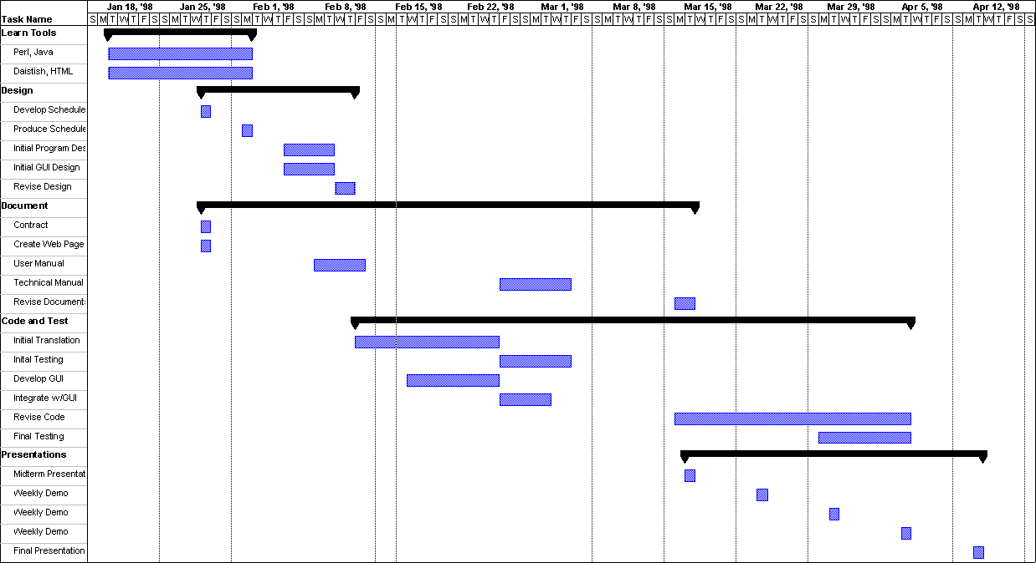

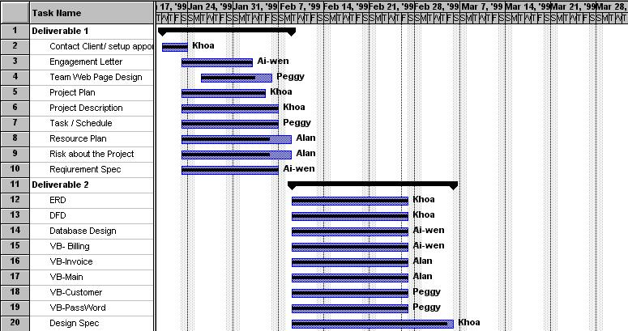

Scheduling Function in an Organization

- Short term, medium term

- Resource are fixed by long term planning

- Tasks are fixed

- processing times
- release dates
- due dates

Scheduling in Manufacturing

Production planning,
master scheduling
Orders, demand forecasts

Capacity
status
Quantities,
due dates

Material requirements planning,
capacity planning
Material
requirements

Scheduling
constraints
Shop orders,
Release dates

Scheduling
and
rescheduling

Detailed
scheduling
Schedule
Scheduling
performance

Dispatching

Shop
status

Shop floor management

Job loading
Data
collection

Shop floor

Scheduling in Services

Status
Database
Database

Forecasts
Data

Scheduling
Yield management
Pricing

Orders,
reservations
Accept/
reject

Customer

Examples

1) Project Scheduling: System Installation

- Development and installation of trading tools for the Frankfurt Stock Exchange by Deutsche Börse group

- 300 software projects, 200 types of employees, 1500 people

- Projects may be interrelated by

- precedence constraints
- milestones
- joint use of resources

- Objective: minimize makespan

2) Hot Strip Mill Production Scheduling

- Integrated steel plant, Acme Steel, Chicago

- The mill transforms large bars of steel (slabs) into coils of sheet
- Select orders and sequence them

- Objectives:

- Minimize set-up times, smooth production
- Minimize waste of energy
- Minimize number of delayed orders

- Constraints:

- Product quality restrictions
- Process efficiency standards

3) Flight Crew Scheduling

- American Airlines: crew costs are the 2nd highest component of direct operating cost

- Allocate flights into crew trips

- Objective: minimize the total cost of flying the schedule

- Cost components: salaries, hotel expenses, etc.

- Constraints:
- limitations of work rules (shaped by a union contract)
- limits on flight time, connection time

4) Robot Scheduling in a Circuit Board Production Line

- Control of robots requires real-time scheduling

- A circuit board must be sequentially processed within a series of chemical tanks

- A board can stay in a tank for a fixed time, otherwise it becomes defective

- Robots move the board from station to station

- Scheduler decides which job to pick next

- Objective: maximize throughput of good parts

- Constraints: fixed sequence for jobs

Material Handling
Hoist

5
4
3
2
1
Chemical Tanks

5) Sequencing of Commercial Breaks by TV Networks

- Management of commercial airtime at Channel 4

- 5 min break may contain 180 spots across 6 regions

- Constraints:

-No overlaps or gaps
-advertisers may specify first or last spot

- Objective: maximize no of advertiser requests

