Corner Pockets

Character: Hunter, Rachel, Alex, Johnny, Cameraman(Jones), ghost

First button: please input your name

Background: It’s an old tradition for NYU Shanghai’s film club to make a movie at the end of every semester. And the whole process is recorded. This time, 5 people are hiking towards an old castle to make a costume drama. While the journey is too long for them to arrive during the daytime, so they decide to find some place to put up for the night. They found an abandoned theater and decided to check whether it’s safe or not.

(picture showing the NYU Shanghai AB)

The main stage:

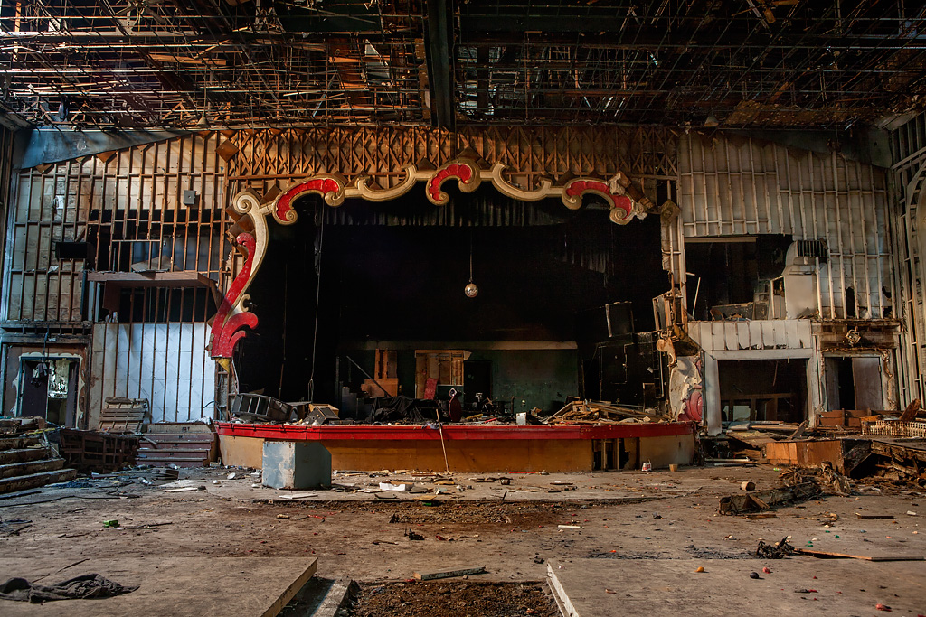

Rachel: Though this place is a little bit messy, currently there is no better choice. So let’s check whether this place is safe or not.

Hunter: But all the doors are locked.

Alex: Look what I have found here. This room is Office of General Services and all of the 5 keys including a master key are here. Let’s choose a key and split up, and just leave the master key here in case of anything unexpected.

(picture showing 4 keys on alex’s hands)

(room arrangements: Johnny 02 L, Rachel 02 R, Hunter 01 L, Alex 01 R)

Johnny: I agree, there’s limited time before the sunset. Let’s move.

(picture showing 4 people turn around and leave for their selected room)

(showing 3 buttons Johnny, Rachel, Hunter)

Button Johnny: (showing the inside environment (has window) of the room and button return)

(Johnny showed up on the position, staring at the camera)

Emm, here is a little bit messy but it’s safe

Button Rachel: (showing the inside environment (has window) of the room and button return)

(Rachel showed up on the position, staring at the camera)

It’s so gloomy here. But it’s safe

Button Hunter: (showing the inside environment (has window) of the room and button return)

(Hunter showed up on the position, staring at the camera)

Safe!

Once all 3 buttons are clicked.

(showing the picture 3 people gather together)

Rachel: It’s weird, where’s Alex?

Johnny: I remember he’s in room 01 R. Let’s go and find him.

(showing the corridor)

Hunter: The door is locked.

Johnny: Me and Rachel are going to get the master key. You stay here Hunter

(show the picture using the master key unlocking the door)

(show the picture alex is cut into 2 pieces)

Rachel: What the hell. What happened!

(show the picture Hunter trying very hard to open the window, maybe trying twice and then open the window)

(show the picture looking down out of the window, there’s no footprint, scary BGM)

Rachel: Ahhhhhhh!

(show the picture of Rachel sitting on the ground, the rope inside her bag drops out Johnny leans against the wall, a ghost appears)

Ghost: Tell me the name of the killer, if it’s right, I will leave you alone and if it’s wrong, everyone will be killed by me!

(show the place for the viewer to fill in the answer)