**Our World**

Scarlet Ng, Kairui Sun, Kevin Xu

1. **Introduction**

In “Our World” we plan to allow the user to create and modify their own landscape through the use of speech and touch. Using key phrases such as “create grass” or “create trees” the user may will these objects into the world while using their sight placement and the VR controllers to control where, how large of an area is taken up, and other factors in generating these items.

First inspired by a showcasing of a program presented in Machine Learning for New Interfaces in 2019, in which subtitles would animate, change in size, font, etc. based on the tone, inclination, volume, and speed of the speaker’s words. Unfortunately we were not able to find the source of the project, but we wanted to recreate this idea in a three-dimensional space but inverted, that is to say instead speech controlling the visuals of the text, the visuals of the text controls the visuals of the landscape. The transition to include landscaping came later, as we felt there was a lack of a visual component in pursuing to recreate only that project. This change was inspired by a project titled, “I Never Promised You A Garden” by PastorPlaczek Studio. As a VR art installation, it sought to allow users to interact with a hanging garden, and depending on the interaction, or lack thereof, the plants would either thrive or die out.

The goal of the project is to allow the user to create a landscape in a more organic way, as opposed to simple UI menus, and rigid placement that we see in many video games, which frequently disrupts immersion into the setting.

1. **Technical Research & Planning**

Technical Work

* Unity
  + UnityEngine.Windows.Speech allows us to capture speech and turn keywords/keyphrases into command triggers.
  + Using a fairly simple script, we can utilize terrain editing tools in game.
  + For immersion, sound design is also important, we can utilize Audio Sources to specify world spaces from which audio comes from.
  + We plan to use 3D models of the keywords to allow the user to build, but can utilize layers to remove them from sight, so that they do not obstruct view and break immersion.
* Media & Modelling
  + A great deal of sound effects can be found online. Since the project can utilize globally usable scripts for object instantiation and speech commands, the focus is mostly on finding clear audio sources and clean models.
  + For what we cannot find in terms of models, we can use Maya to create our own. Stylistically we are not going for pure realism, so for the most part low-poly models will make do, saving time.

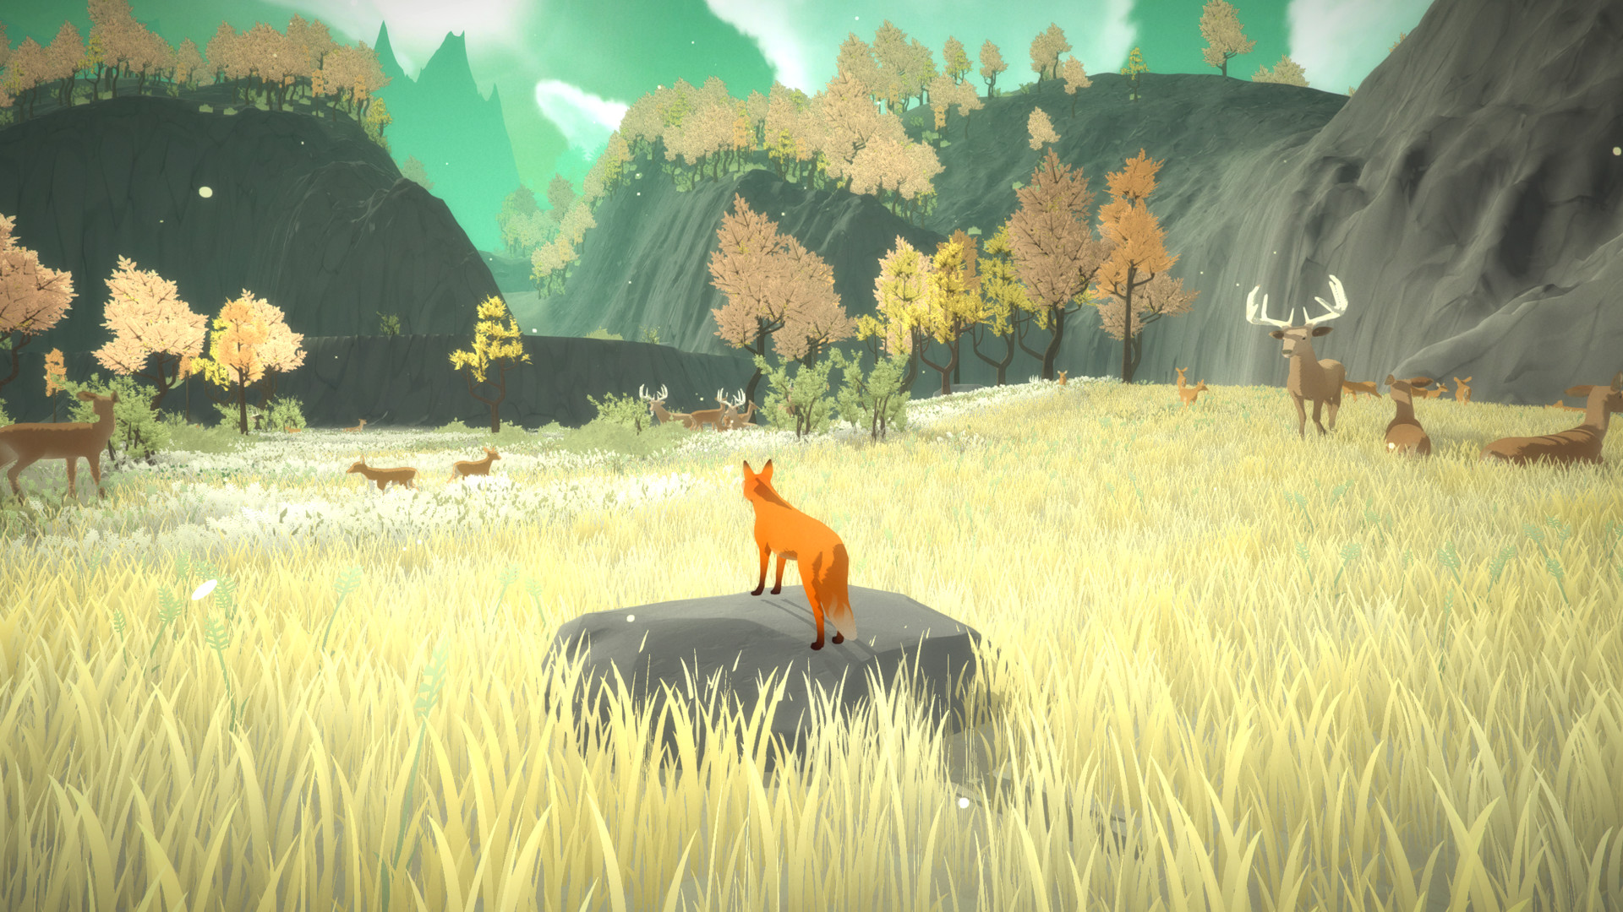

*Example of target style. Source: The First Tree, created by David Wehle.*

Plans For Production

Week 1 (11/10-11/17):

Scarlet, Max, Kevin - Idea discussion, preliminary research on feasibility.

Week 2 (11/17-11/24):

Kevin - Technical work completed (keyphrase recognition, item generation, and controls)

Scarlet, Max - Modelling & Media Creation/Collection

Week 3 (11/24-12/1):

Scarlet Max, Kevin - Modelling & Media Creation/Collection

Week 4 (12/1-12/8):

Kevin, Scarlet, Max - Overall refinement (QA)

1. **Testing**

Speech Recognition Example (“Create” enables creation mode for 5 seconds, “grass” can then be chosen):

using System;

using System.Collections;

using System.Collections.Generic;

using UnityEngine;

using UnityEngine.Windows.Speech;

using System.Linq;

public class **NewBehaviourScript** : MonoBehaviour

{

private bool createMode = false;

private KeywordRecognizer kwr;

private Dictionary<string, Action> kw = new Dictionary<string, Action>();

void **Start**()

{

kw.Add("create", () =>

{

StartCoroutine("CreateActivated");

});

kw.Add("grass", () =>

{

if (createMode)

{

print("grass working");

}

});

kwr = new KeywordRecognizer(kw.Keys.ToArray());

kwr.OnPhraseRecognized += KeywordRecognized;

kwr.Start();

}

void KeywordRecognized(PhraseRecognizedEventArgs args)

{

Action kwA;

if (kw.TryGetValue(args.text, out kwA))

{

kwA.Invoke();

}

}

IEnumerator CreateActivated()

{

createMode = true;

print("Create");

for (;;)

{

yield return new WaitForSeconds(5);

createMode = false;

print("Create Disabled");

yield break;

}

}

}

1. **Sources Cited**
2. Unknown, Speech to Text Project
3. PastorPlaczek Studio. I Never Promised You A Garden. 2019, Virtual Reality Installation. <https://www.youtube.com/watch?v=57wDHjpPoac>
4. Wehle, David. The First Tree. 2017, Video Game.